


Technician Guidance Sheets
TGS / 09

Safe Use: Sedgwick MB/CP Planer Thicknesser

Issued by Technician Support Service

Date October 2005

Objectives - The objectives of this bulletin are to ensure the safe use of the Sedgwick Planer Thicknesser and to highlight the functional changes in the new machines when compared to previous models used in secondary schools.

Persons responsible – Support Service Technicians and Technical Teaching Staff

Part 3 Safe Use: Sedgwick MB/CP Planer Thicknesser - Index
Section |  | Title | Page
1 |  | Aims and Objectives | 2 - 3
 |  | Planer Thicknesser – labelled diagram | 4
2 |  | Usage | 5
3 |  | Hazards | 5
4 |  | Control Measures | 5 – 7
5 |  | Safety Checks Before Use:
 | 5.1 | Clear Working Area around the Planer Thicknesser | 8
 | 5.2 | Workpeice | 8
 | 5.3 | Ensure the Planer Thicknesser is Isolated | 8
 | 5.4 | Extraction Hood | 8
 | 5.5 | Bridge Guard | 9
 | 5.6 | Rear Cutterblock Guard | 9
 | 5.7 | Cutterblock | 9
 | 5.8 | Anti-Kickback Fingers | 10
 | 5.9 | Feed Rollers | 10
6 |  | Fence | 11
7 |  | Powering the Planer Thicknesser:
 | 7.1 | Energise the Planer Thicknesser | 11
 | 7.2 | Testing the Planer Thicknesser Stopping Systems | 12 – 13
8 |  | Feeding Material Through the Planer Thicknesser:
 | 8.1 | Push Blocks | 14
 | 8.2 | Feed Speed | 14
 | 8.3 | Take-Off | 14
 | 8.4 | Blades | 14
9 |  | Cutting Material:
 | 9.1 | Edge Planing (Squaring) | 15 - 16
 | 9.2 | Thicknessing | 17 - 18
 | 9.3 | Bevelling or Chamfering | 19
10 |  | Power Down the Planer Thicknesser | 19
11 |  | Leaving the Planer Thicknesser Safe for the Next User | 19
12 |  | Fault Reporting | 20
13 |  | Reference Material | 20

Safe Operation of the Sedgwick MB/CP Planer Thicknesser

AIMS AND OBJECTIVES

Aims
To instruct teaching and technician staff in the safe use of the Sedgwick Planer Thicknesser and to highlight and demonstrate the functional changes in the new machines when compared with previous models used in secondary schools.

General Objectives

To demonstrate the safety precautions necessary for the safe operation of the planer thicknesser

To demonstrate the functions of the guards and safety devices.

To demonstrate how to set the tools and prepare the planer thicknesser for safe use.

To demonstrate how to operate the planer thicknesser to carry out its functions safely.

To highlight any modifications Technician Support Services have made to the planer thicknesser.

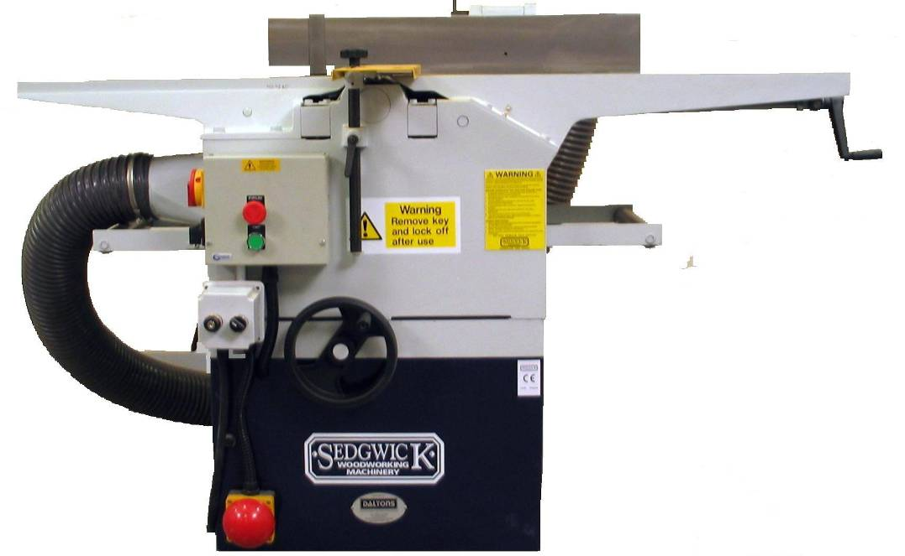

Specific Objectives

Know and understand the hazards associated with use of the planer thicknesser.

Know, observe and heed the advice of, the safety signs which apply to the planer thicknesser.

Know what personal protective equipment (PPE) is mandatory when using the planer thicknesser.

Know that the planer thicknesser requires dust extraction (LEV) operating when the machine is in use.

Know that if the dust extraction (LEV) system is faulty or under repair, the planer thicknesser must not be used.

Become familiar with the parts of the planer thicknesser and their functions.

Know the guarding requirements of the planer thicknesser.

Be able to position and adjust the guards correctly.

Ensure that the drive/belt mechanism access is locked.

Know that the planer thicknesser must be electrically isolated before making any adjustments or cleaning.

Be aware of the materials that can and cannot be machined.

Know not to attempt to cut multiples of materials.

Be aware of the location and function of the emergency stops.

Become familiar with the “power up” procedures for the planer thicknesser.

Know and adopt the correct position/stance when using the planer thicknesser.

Understand the use of “push sticks” and when to use them.

Know to feed the timber into the machine with firm and steady pressure, not to force timber through.

Become familiar with the “power down” procedures and isolation of the planer thicknesser.

Know to leave the machine clean, tidy and in a safe condition when work is completed.

Know to never leave a planer thicknesser unattended when the machine is running.

Know to never leave a planer thicknesser, after use, so that it can be readily “powered up” and used by unauthorised users.

Know to never leave the planer thicknesser keys in an area where they can be easily accessed by unauthorised persons.

Know to report any damage or faults immediately and who to report them to.

Sedgwick MB/CP Planer Thicknesser

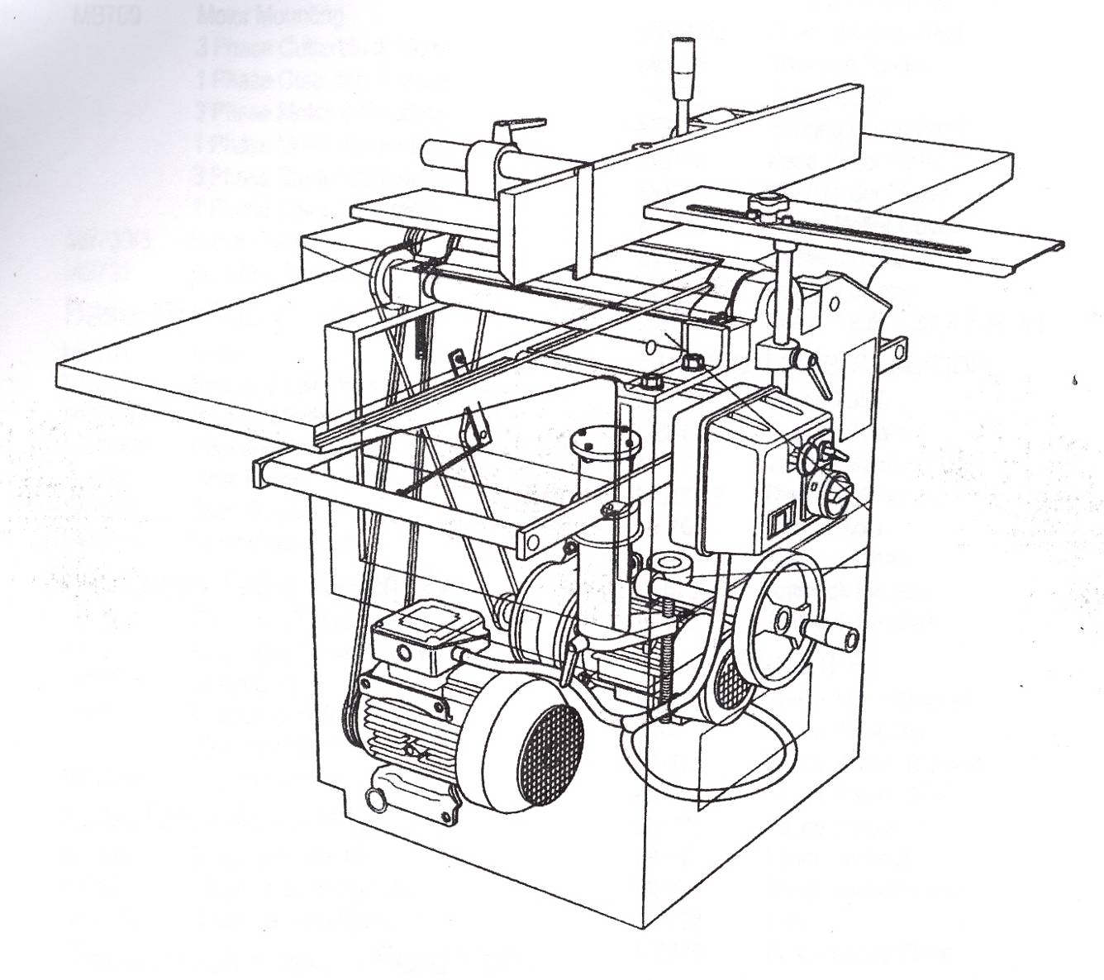

1
3
2
4
13
8
7
6
5
11
10
12
9
14
15
16

1. | Fence Cant Lock | 9. | Surface Table Rise and Fall Handle
2. | Fence Lateral Lock | 10. | Rise and Fall Handwheel
3. | Fence | 11. | Thickness Table Vertical Lock
4. | Cutterblock Guard (Bridge Guard) | 12. | Start / Stop Controls
5. | Cutterblock Guard – Horizontal Lock | 13. | Isolator
6. | Cutterblock Guard – Vertical Lock | 14. | Mushroom headed Footstop
7. | Rear Cutterblock Guard | 15. | Surfacing Table – Infeed Table
8. | Thicknessing Bed | 16. | Surfacing Table – Outfeed Table

USAGE
Softwood, hardwood, and composite materials. It should be noted that schools must never use this machine to machine metal.

HAZARDS

Work pieces can be “kicked back” towards the operator

Planer blades breaking, causing ejection of parts of blade into the room

Hands and fingers can contact blade, gearing, pulleys and prime mover motor

Entanglement: clothing, long hair and loose jewellery can become entangled

Wood dust can be generated

Noise generated could be damaging to the users hearing

Environmental: keep area around machinery clear of surplus materials, wood waste and other tripping or slipping hazards

Inadvertent starting/stopping of the machine

Unauthorised persons using the machine

CONTROL MEASURES

Safety Signs
Blue – Mandatory Instructions Red – Prohibatory Yellow - Warning







Personal Protective Equipment (PPE)

Goggles (BSEN-166-349B)

Ear Protection

Dust masks must be worn at all times when using the planer thicknesser (FFP2)

Loose clothing must be secured and long hair tied back

Where two (or more) items of personal protective equipment are used simultaneously, ensure that they are compatible and are as effective together as they are separately.

Emergency Stop Systems

Room Emergency Stop System – various sites around the room

Mushroom Headed Footstop – situated at the base of the planer thicknesser

Braked Motor which will bring the blades to stop in less than 10 seconds – in line with PUWER 98 Regulations by December 2005 all planer thicknessers should be fitted with a braking device to ensure that the run down time does not exceed 10 seconds

Guards

Bridge Guard (Front Cutterblock Guard) – guards the cutterblock when surfacing and thicknessing.

Rear Cutterblock Guard – a hinged guard designed to guard the part of the cutterblock that is on the side of the fence remote from the bridge guard. There is no need for its removal from the fence.

The Rear Drive Guard – should only be removed for maintenance or cleaning.

Anti Kickback Fingers
The function of the anti kickback fingers is to drop and lock into the face of the workpeice in the event of kickback, thereby preventing it from being ejected from the machine.

Push blocks (shoe)
Push blocks (shoe) should be available for use at all times and should be used as appropriate. (See Push blocks 8.1)

Electrically Interlocked Extraction System (not all systems are electrically interlocked)
The planer thicknesser should only be used in conjunction with a suitable dust extraction system, most systems are interlocked. The extraction hood will have to be positioned at the machine appropriately for planing or for thicknessing.

Controlled Access to Machines

Restricted access – the area where the planer thicknesser is used should not be accessed by pupils.

Planer thicknesser is controlled by a keyswitch.

Planer thicknesser keys must be controlled by a competent member of staff and never left where unauthorised persons can easily access them. Schools must have in place a system for the safe and secure management of the machine keys.

SAFETY CHECKS BEFORE USE

Clear Working Area around the Planer thicknesser
Before use, ensure that the area around the planer thicknesser is clear of surplus waste materials, wood waste products and /or models that may hinder the safe use of the planer thicknesser.

Workpeice
Always check the condition of the material to be used: examine the workpeice carefully for faults that may affect the machining process, particularly foreign bodies such as nails, staples etc. Consider also the direction of the grain, the shape of the timber, whether it is bowed or twisted, and the position of defects such as knots, wavy edges etc.

Ensure the Planer thicknesser is Isolated
Before carrying out any safety checks the planer thicknesser must be isolated from the power supply.

Check the machine isolator is in the “off” positioned (maybe padlocked)

Check that the machine key is not in the keyswitch

Extraction Hood
The extraction hood on the planer thicknesser is not fixed, instead the hood is positioned over the cutterblock when thicknessing, or located in the thicknessing bed under the cutterblock when planing or surfacing.

Bridge Guard
The yellow pillar mounted guard, it is provided with a two hand locking arrangement, one for the vertical plane and one for the horizontal plane.

Check that the bridge guard is free from damage.

Check that the bridge guard can be easily adjusted and locked in position.

Secure the bridge guard in position, covering the cutterblock.

Bridge Guard
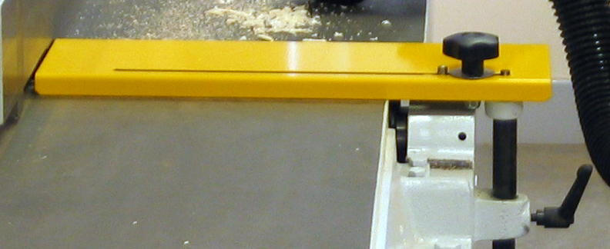
Horizontal
Adjustment
Vertical Adjustment

Rear Cutterblock Guard
To the rear of the fence is mounted a hinged guard, designed to guard the part of the cutterblock that is on the side of the fence remote from the bridge guard. The purpose of the rear cutterblock guard is to guard the cutterblock when the fence is moved across the surface table. There is no need for its removal from the fence.

Check that the rear cutterblock guard is in place and free from damage.

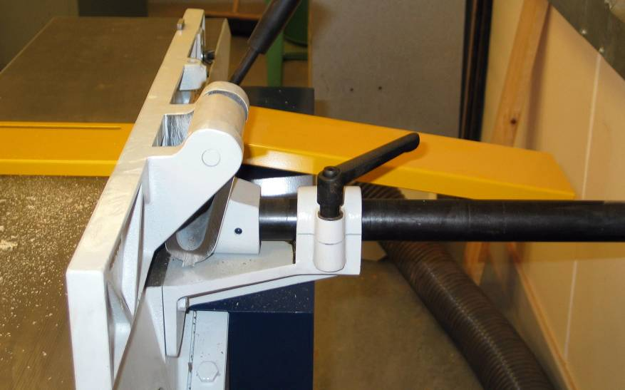
Rear Cutterblock
Guard

Cutterblock

Adjust the bridge guard to expose the cutterblock, carefully turn it slowly by hand in a clockwise direction.

Check that the blades are not cracked or distorted.

Check that the cutterblock is free from grease, rust and wood residue.

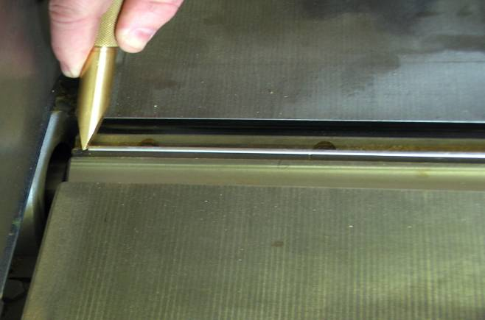
Blade
Cutterblock
Only technicians trained in the safe use and maintenance of the planer thicknesser should attempt to replace the blades in the cutterblock.

Anti Kickback Fingers
The anti kickback fingers are located above the thicknessing bed, their function is to drop and lock into the face of the workpeice in the event of kickback, thereby preventing it from being ejected from the machine.

All fingers should be in place and moving freely.

Check for any build up of waste wood or residue.

Feed Rollers
Feed rollers at the front and rear of the cutterblock push and pull the wood through the rotating cutter knives. The infeed roller is located at the front of the block and is made of serrated steel. In order for it to operate effectively it must be kept free of resin. The metal serrations will be imprinted on the wood as it is forced under the cutterblock; these marks are then removed by the cutting of the knives. At the back of the cutterblock are a smooth metal roller and a plain feed roller. Each roller is spring loaded to accommodate variations in wood thickness. The speed of the feed rollers can be adjusted, using the feed speed control. The speed is set depending upon the wood being machined. (see pg 13 section 8.2)

Check feed rollers move freely and are free from damage.

Inspect feed rollers for residue build up. Residue build up can be removed using a wire brush or a flat nose screw driver.

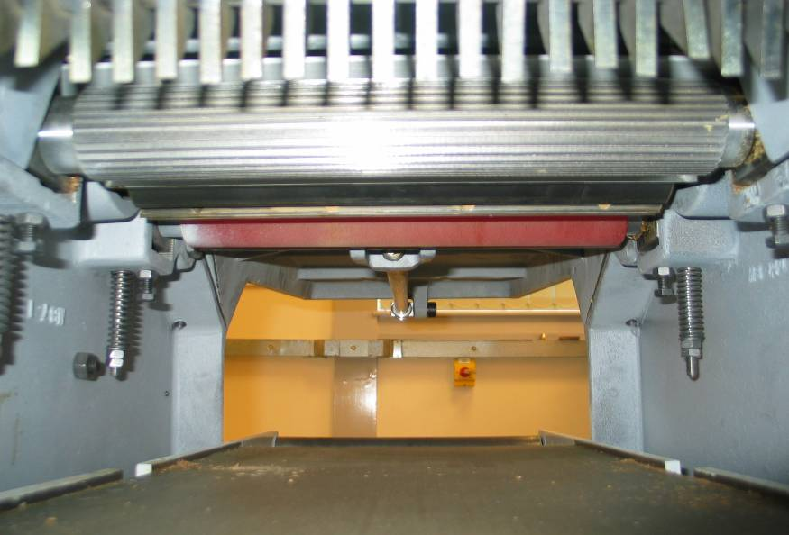
Infeed
Feed Roller
Anti Kickback
Fingers
Plain
Feed Roller

FENCE
The purpose of the fence is to ensure the edge of the workpeice is square when edging or planing. The fence should normally be set at an angle of 90º to the table, although the angle can be adjusted as required. Before planing, the angle of the fence should be checked using an engineer square and adjusted as required using the Fence Cant Lock.

Fence Cant Lock
Fence
Fence Lateral Lock

The fence can also be adjusted across the table. To adjust the fence across the table, loosen the bridge guard and slide it back the full length of the slot. Loosen the Fence Lateral Lock and slide the fence across the table to the required position and then lock in position with the Lateral Fence Lock. When the fence is moved across the table the cutterblock behind the fence is protected by the rear cutterblock guard. Set the bridge guard and lock in position.

POWERING THE PLANER THICKNESSER

Energise the Planer thicknesser

Ensure that the extraction gate to the planer thicknesser is open and the extraction gates to the circular saw are closed.

Switch on the 3-phase power supply to the work room, this maybe controlled by a keyswitch

Switch the machine isolator to the “on” position (situated on the wall, close to the machine)

Remove the padlock from the planer thicknesser power isolator, and switch “on”

With the machine key in the keyswitch, switch to the “on” (right) position, the planer thicknesser now has power
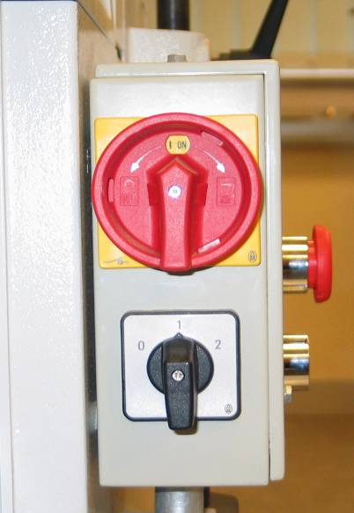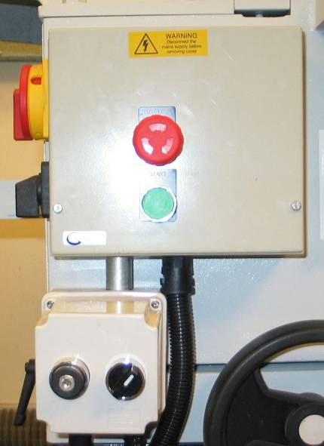
Planer thicknesser
Power Isolator
Keyswitch
Start Button
Feed Speed
Control
Red Stop
Button
Motor Brake
Release
Switch

Control Panel at the front of the machine.

Testing the Planer thicknesser Stopping Systems
If the planer thicknesser has an interlocked extraction system, the extraction will automatically switch on when the saw is energised. If the extraction system is not interlocked, it will have to be switched on prior to machine being energised.

Press the green start button, the machine will start and the cutterblock will turn, press the Red Stop Button on the control panel, the planer thicknesser will come to a complete stop in less than 10 seconds.

Reset the Red Stop Button: turn to the right to unlock and the button will reset.

Press the green start button, the machine will start, depress the Mushroom Headed Footstop, the planer thicknesser will come to a complete stop in less than 10 seconds.

Reset the Mushroom Headed Footstop by pulling the mushroom head out until you hear it “click” back into position.

The planer thicknesser has a Motor Brake Release Switch which releases the brake from the cutterblock, and is used when changing blades on the cutterblock or carrying out essential maintenance.
Only technicians trained in the safe use and maintenance of the planar thicknesser should change the blades on the cutterblock or carrying out essential maintenance.

The Mushroom Headed Footstop is essentially part of the emergency stopping system and should not be routinely used to stop the planer thicknesser.

The Emergency Stopping System will be tested regularly by the Support Service Technicians as part of the routine maintenance of the machine tools.

The planer thicknesser is now ready for use.

FEEDING MATERIAL THROUGH THE PLANER THICKNESSER

It is essential when cutting, to ensure that hands are correctly positioned and kept clear of the cutting area “gap” at the cutterblock. Hands should never move “over” the cutterblock, but should move around and over the bridge guard avoiding the “gap”. Push blocks are used to avoid hands coming close to the cutterblock.

Push Blocks (shoe)
In some operations push blocks should be used, especially when planing short pieces of timber (minimum length for planning 300mm) where it is necessary to pass the workpeice between the edge of the bridge guard and the fence. They should be constructed so as to give the operator a firm grip and so reduce the risk of hands coming into contact with the cutterblock.

Feed Speed
The Feed Speed Control controls the speed at which the feed rollers turn, and therefore the speed at which the wood is fed through the cutterblock when thicknessing.

The feed speed is only adjusted when carrying out thicknessing operations and should be set as follows:
For hard woods (e.g. mahogany) the feed speed should be set at (1)
For soft woods (e.g. pine) the feed speed should be set at (2)
For surfacing, planing and edging operations the feed speed should be set at (0)

After thicknessing, if the workpeice has cutter marks on the surface being dressed, then the feed speed is too fast and should be reduced.

Take - Off
The Sedgwick planer thicknesser is essentially designed to be used by only one person at a time.

Blades
Monoblock with tersa cutters, the design of this tool allows the clamping of the cutters using centrifugal force. The exactness of the position is +/- 0.02mm, guaranteed on all the sharp edges and on the whole length of the planing shaft. The tersa cutters are double sided, and must not be sharpened. Each knife has two cutting faces and if one side is damaged the knife can be reversed, although ideally all four knives should be reversed / replaced at the same time.

Contact TSS in the first instance for replacement

Only technicians trained in the safe use and maintenance of the planar thicknesser should change the blades on the cutterblock or carrying out essential maintenance.

CUTTING MATERIAL

Edge Planing (Squaring)
When edging, the wood is passed between the end of the bridge guard and the fence. It is recommended that the minimum length of timber that can be safely edged/planed is 300mm.

Ensure that the planer thicknesser is isolated before making any adjustments

Position the extraction hood; the hood is designed to sit on the thicknessing bed, and should be inserted hollow side up, with the exhaust outlet below the fixed out-feed table. The lug on the underside of the hood, attached to the exhaust outlet, should locate against the end of the thicknessing bed. Raise the table until the nylon slips are sealed against the underside of the surfacing table, with care being taken that the anti-kickback fingers are not fouled when the bed is wound up. Lock in position using the thickness table vertical lock.

Check that the fence is set at an angle of 90º with the table, using an engineers square

Place the workpeice between the fence and the blade guard, and adjust the blade guard to a distance of 8mm from the workpeice

The depth of cut is set by adjusting the height of the infeed table, using the surface table rise and fall handle, and the in-feed table guide. This in effect drops the infeed table in relation to the cutterblock, therefore the greater the gap the deeper the cut. For normal working it is good practice to set the amount of cut to 1mm for fine edging.

During operation the workpeice is pressed up against the fence and the in-feed table by the left hand, which is positioned at the top of the workpeice and not over the cutterblock. This will produce an edge that is square to the face of the timber. The workpeice is moved forward regularly by the right hand, again positioned at the top of the workpeice and not over the cutterblock and eventually, the workpeice is moved over the cutterblock using a pushblock in the right hand to feed through the last 300mm of material.

When edging is complete, return infeed table to zero

Remove rise and fall handle and store safely for future use
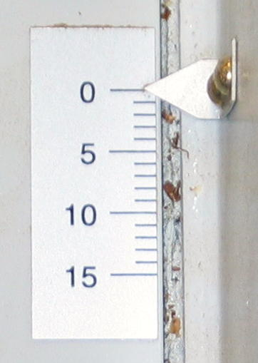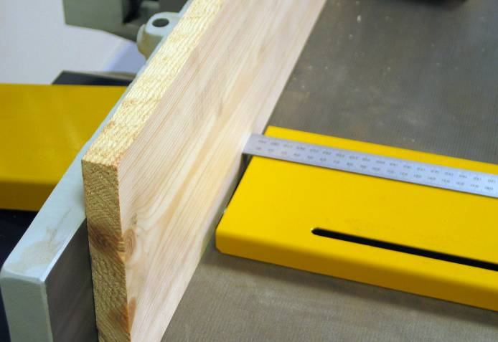

Infeed table guide Bridge Guard set at 8mm from material

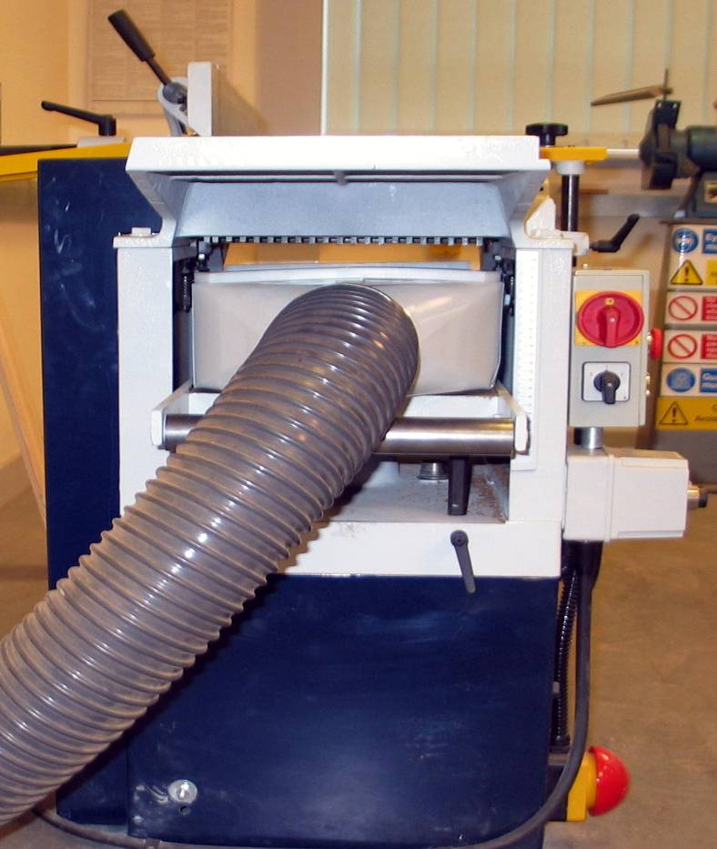

Position of extraction hood when edge planing or surfacing

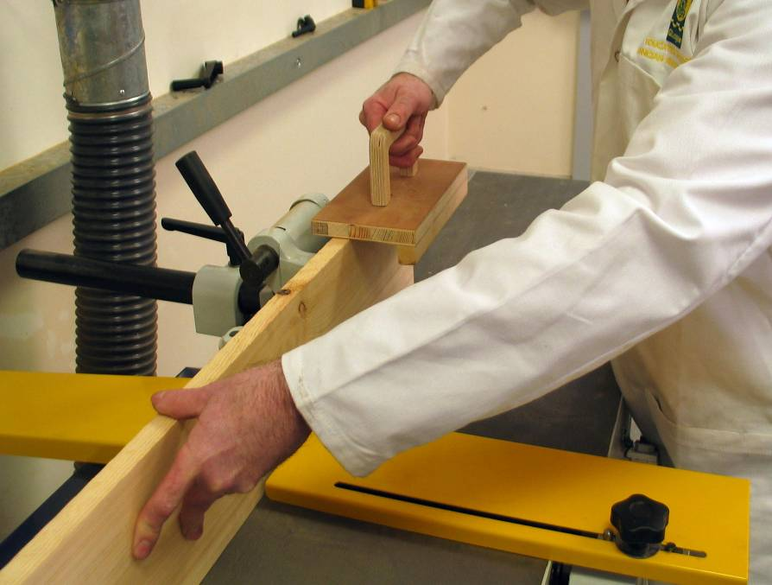

Position of hands and use of “push block” when edge planing.

Note: that the leading unprotected hand is in front of the cutterblock and moving away from the cutterblock as the edge planning proceeds.

Thicknessing
When thicknessing the wood is passed through the thicknessing bed, under the surfacing table. It is recommended that the minimum length of material that can be safely thicknessed is 800mm.

Ensure that the planer thicknesser is isolated before making any adjustments.

Position the fence to the rear of the surfacing table.

Place the extraction hood centrally over the cutterblock, hollow side down, with the exhaust outlet pointing toward the in-feed table. Bring the bridge guard down over the hood and lock it in position between the two welded straps.

Set the depth of cut using the thicknessing table rise and fall handwheel (with graduated guide) and lock in position using the thickness table vertical lock. Maximum material to be removed in one cut should be restricted to 2mm.

After setting the depth of cut, ensure that the anti-kickback fingers are not restricted by the thicknessing bed, the anti-kickback fingers must be free during thicknessing operations.

Set the feed speed depending upon the type of wood being machined: hard wood (1) soft wood (2)

During operation the material should be gently fed into the thicknessing bed, where the feed rollers will catch and feed the material through. The operator should then move to the opposite side of the machine and receive the dressed material.

Always check measurements between cuts.

Repeat as above, until the desired amount of material has been removed.

When thicknessing is complete, return the feed speed to (0).

Note: Thin sections of timber cannot be reduced in the thickness i.e. 10mm or less, as the anti-kickback fingers will become jammed on the thickness table. The use of an auxiliary table (false fence) for thin sections of material is strictly prohibited

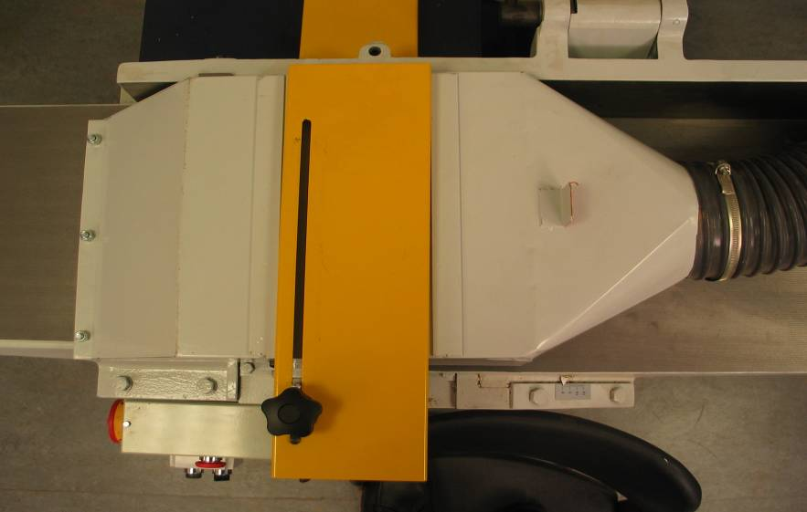

Position of extraction hood when thicknessing

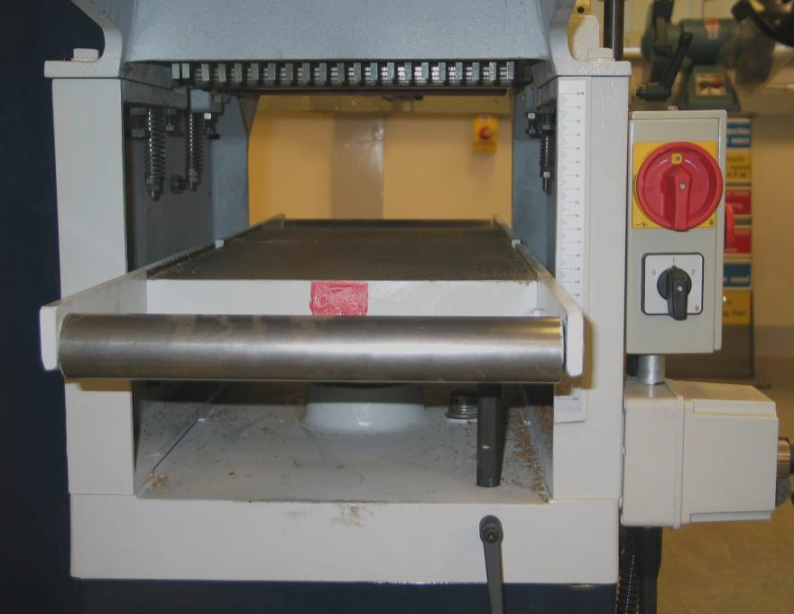
Thicknessing Bed
(Note: the red square)
Graduated Scale
Thicknessing Table Vertical Lock

Technician Support Service advice that a red square be marked on the thicknessing bed to indicate the position of the extraction hood “lug” when the hood is located in the thicknessing bed for edge planning or surfacing.

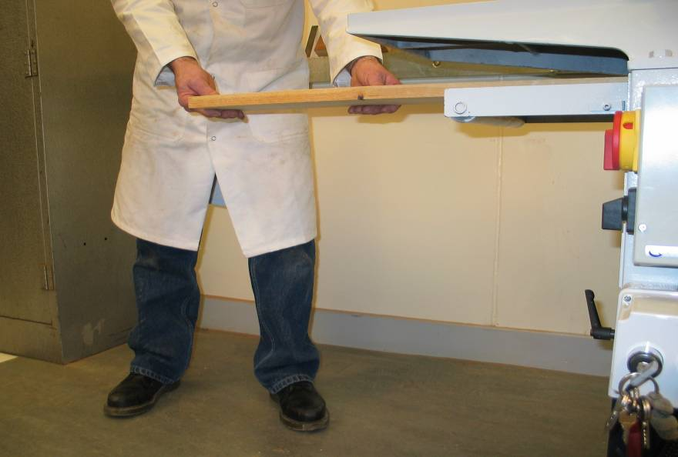

Position of operator when feeding material for thicknessing, the operator should always stand to the side of the material when feeding into the thicknesser.

Bevelling or Chamfering
Bevelling or chamfering can be achieved by adjusting the fence to the required angle, using the Lateral Cant Lock. The angle required is set using a sliding bevel or a protractor.
Bevelling or chamfering should only be carried out by technicians trained in the safe use and maintenance of the planer thicknesser.

Note:
The use of the planer thicknesser for the cutting of any rebate, tenon, or groove is strictly prohibited as the cutterblock above the table cannot be effectively guarded.

Never leave the plane thicknesser unattended while the blade is running.

POWER DOWN THE PLANER THICKNESSER

Press the red stop button on the control panel to stop the planer thicknesser, the cutterblock should come to a complete stop within 10 seconds

Turn the keyswitch to the off position and remove the key

Switch off the planer thicknesser power isolator and replace the padlock

Switch of the planer thicknesser isolator

LEAVING THE PLANER THICKNESSER SAFE FOR THE NEXT USER

Clear the surfacing table and the thicknesser bed of all debris and dust, using the Hepa filter Vacuum Cleaner as appropriate

Ensure that the surface table is returned to the zero position

Remove the extraction hood and store safely, on top of the surfacing table covering the cutterblock and secured by the bridge guard

FAULT REPORTING

If any fault or damage is found when using the planer thicknesser:

Switch off the planer thicknesser

Isolate the planer thicknesser and lock off the power using the padlock

Report any faults, defects or damage immediately to the appropriate Support Service Technician or the Senior Support Service Technician, who will arrange for any necessary maintenance or repairs to be carried out

If any fault or damage to the planer thicknesser is reported, the following action should be taken by the appropriate Support Service Technician:

Ensure that the planer thicknesser has been isolated from the power supply and that the power is locked off using the padlock

Attach a padlock to the planer thicknesser isolator and retain the key

Label the planer thicknesser “Do Not Use – Under Repair”

If appropriate carry out necessary repair or maintenance

If necessary contact TSS to arrange for repair

REFERENCE MATERIAL
This document was compiled with reference made to the following material:

- BS 4163:2000 Health and Safety for Design and Technology in Schools and similar establishments – Code of Practice
- Sedgwick MB/CP Planer Thicknesser – Operation and Maintenance Instructions 2003
- The Design and Technology Association (DATA) – A Guide for Consultants, Trainers and Teachers for Health and Safety Training
- Technical Education – A Code of Practice
- Technician Support Service – Training Material

