


Technician Guidance Sheets
TGS / 07

Safe Use: Centauro Bandsaw

Issued by Technician Support Service

Date: October 2005

Revised: July 2013

Objectives - The objectives of this bulletin are to ensure the safe use of the Centauro Bandsaw and to highlight the functional changes in the new machines when compared to previous models used in secondary schools.

Persons responsible – Support Service Technicians and Technical Teaching Staff

Part 1 Safe Use: Centauro Bandsaw - Index
Section |  | Title | Page
1 |  | Aims and Objectives | 2 - 3
 |  | Bandsaw Diagram - labelled | 4
2 |  | Usage | 5
3 |  | Hazards | 5
4 |  | Control Measures | 5 – 6
5 |  | Safety Checks Before Use:
 | 5.1 | Clear Working Area around the Bandsaw | 7
 | 5.2 | Workpeice | 7
 | 5.3 | Ensure the Bandsaw is Isolated | 7
 | 5.4 | Guards | 7 - 8
 | 5.5 | Tension of the Blade | 8
 | 5.6 | Table Block Insert | 9
 | 5.7 | Blade Guides | 9 – 10
6 |  | Powering the Bandsaw:
 | 6.1 | Energise the Bandsaw | 11
 | 6.2 | Testing the Bandsaw Stopping Systems | 12
7 |  | Preparing the Bandsaw for Use:
 | 7.1 | Fence Guide | 13
 | 7.2 | Adjusting the Blade Guards | 13 – 14
8 |  | Feeding Material Through the Bandsaw:
 | 8.1 | Push Sticks | 14
 | 8.2 | Feed Speed | 15
 | 8.3 | Take-Off | 15
 | 8.4 | Blades | 15
9 |  | Cutting Material:
 | 9.1 | Cutting with the Fence Guide using a “Push Stick” | 15
 | 9.2 | Cutting without the Fence Guide using a “Push Stick” | 16
 | 9.3 | Cutting without the Fence Guide (Free Hand) | 16
 | 9.4 | Cutting at an angle (Tilt Mechanism) | 17
 | 9.5 | Curved and Irregular Cuts | 17
 | 9.6 | False Fence | 17
10 |  | Power Down the Bandsaw | 18
11 |  | Leaving the Bandsaw Safe for the Next User | 18
12 |  | Fault Reporting | 19
13 |  | Reference Material | 19

Part 1 Safe Use: Centauro Bandsaw

AIMS AND OBJECTIVES

1.1 Aims
To instruct teaching and technician staff in the safe use of the Centauro Bandsaw and to highlight and demonstrate the functional changes in the new machines when compared with previous models used in secondary schools.

1.2 General Objectives

To demonstrate the safety precautions necessary for the safe operation of the bandsaw.

To demonstrate the functions of the guards and safety devices.

To demonstrate how to set the tools and prepare the bandsaw for safe use.

To demonstrate how to operate the bandsaw to carry out its functions safely.

To highlight any modifications Technician Support Services have made to the bandsaw.
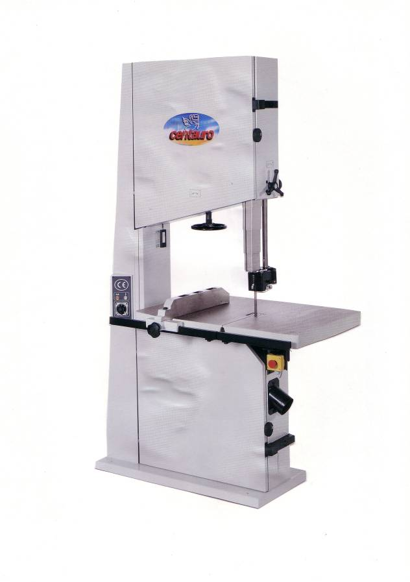

1.3 Specific Objectives

Know and understand the hazards associated with use of the bandsaw.

Know, observe and heed the advice of, the safety signs which apply to the bandsaw.

Know what personal protective equipment (PPE) is mandatory when using the bandsaw.

Know that the bandsaw requires dust extraction (LEV) operating when the machine is in use.

Know that if the dust extraction (LEV) system is faulty or under repair, the bandsaw must not be used.

Become familiar with the parts of the bandsaw and their functions.

Know the guarding requirements of the bandsaw.

Be able to position and adjust the guards correctly.

Ensure that the drive/belt mechanism access is locked.

Know that the power to the bandsaw must be switched off before making any adjustments or cleaning.

Be aware of the materials that can and cannot be machined.

Know not to attempt to cut multiples of materials.

Be aware of the location and function of the emergency stops.

Become familiar with the “power up” procedures for the bandsaw.

Know and adopt the correct position/stance when using the bandsaw.

Understand the use of “push sticks” and when to use them.

Know that the bandsaw is designed to be used by only one person at a time, there should never be anyone positioned at the back of the bandsaw assisting in “taking-off” materials.

Become familiar with the “power down” procedures and isolation of the bandsaw.

Know to leave the machine clean, tidy and in a safe condition when work is completed.

Know to never leave a bandsaw unattended when the machine is running.

Know to never leave a bandsaw, after use, so that it can be readily “powered up” and used by unauthorised persons.

Know to never leave the bandsaw keys in an area where they can be easily accessed by unauthorised persons.

Know to report any damage or faults immediately and know who to report them to.

C600 Centauro Bandsaw

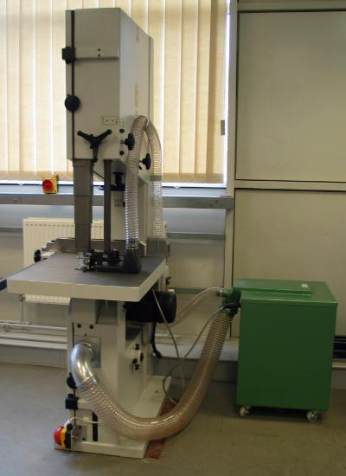
Flywheel Tilt Handle
Blade Tensioning Hand Wheel
Extraction at Blade
Power Panel
Electrically Interlocked Extraction Unit
Bandsaw Isolator

Fence Guide
Telescopic Blade Guard
Blade Guard Locking Handle
Perspex
Blade Guard
Blade Guard Adjustment Handle
Fence Guide
Locking Handle

Extraction Beneath Saw Table
Mushroom - Headed Footstop

2 USAGE
Softwood, hardwood, composite materials and plastics. It should be noted that schools must never use this machine to cut metal.

3 HAZARDS

3.1 Work pieces jamming

3.2 Saw blade breaking, causing ejection of parts of blade into the room

3.3 Hands and fingers can contact blade, gearing, pulleys and primemover motor

3.4 Entanglement: clothing, long hair and loose jewellery can become entangled

3.5 Wood dust can be generated

3.6 Noise generated could be damaging to the users hearing

3.7 Environmental: keep area around machinery clear of surplus materials, wood waste and other tripping or slipping hazards

3.8 Inadvertent starting/stopping of the machine

3.9 Unauthorised persons using the machine

4 CONTROL MEASURES

4.1 Safety Signs
Blue – Mandatory Instructions Red – Prohibatory Yellow - Warning



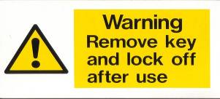

4.2 Personal Protective Equipment (PPE)

4.2.1 Goggles (BSEN-166-349B)

4.2.3 Ear Protection

4.2.4 Loose clothing must be secured and long hair tied back

Where two (or more) items of personal protective equipment are used simultaneously, ensure that they are compatible and are as effective together as they are separately.

4.3 Emergency Stop Systems

4.3.1 Room Emergency Stop System – various sites around the room

4.3.2 Mushroom Headed Footstop – situated at the base of the bandsaw

4.3.3 Braked Motor which - will bring the blade to stop in less than 10 seconds – in line with PUWER 98 Regulations by December 2005 all bandsaws should be fitted with a braking device to ensure that the run down time does not exceed 10 seconds

4.4 Guards

4.4.1 Blade Guards – Telescopic Blade Guard, Perspex Blade Guard and under table Bottom Guide Guard

4.4.2 Access Doors to the flywheels and the blade have micro switches fitted which, if the doors are opened when the saw is in operation, trigger the braked motor and bring the blade to a complete stop within 10 seconds. Access Doors must not be opened until the blade has come to a complete stop (See Guards section 5.4.2).

4.5 Push Sticks
Push sticks should be available for use at all times and should be used as appropriate. (See Push Sticks section 8).

4.6 Electrically Interlocked Extraction System

4.6.1 Under table extraction

4.6.2 Extraction site at the blade

4.7 Controlled Access to Machines

4.7.1 Bandsaw “power panel” – padlocked

4.7.2 Bandsaw controlled by keyswitch

4.7.3 Bandsaw keys must be controlled by a competent member of staff and never left where unauthorised persons can easily access them. Schools must have in place a system for the safe and secure management of the machine keys.

5 SAFETY CHECKS BEFORE USE

5.1 Clear Working Area around the Bandsaw
The area around the bandsaw should be regularly checked to ensure that it is clear of surplus waste materials, wood waste products and / or models that may hinder the safe use of the bandsaw.

5.2 Workpeice
Always check the condition of the material to be used: examine the workpeice carefully for faults that may affect the machining process, particularly foreign bodies such as nails, staples etc. Consider also the direction of the grain, the shape of the timber, whether it is bowed or twisted, and the position of defects such as knots, wavy edges etc.

5.3 Ensure the Bandsaw is Isolated (before carrying out the following checks)

5.3.1 Check the machine isolator is in the “off” position

5.3.2 Check the bandsaw power button at rear of machine is in “off” position (padlocked)

5.4 Guards

5.4.1 Examine the Perspex Blade Guard and the Telescopic Blade Guard for any signs of damage before use. Any damage found should be reported to the appropriate Support Service Technician or the Senior Support Service Technician.

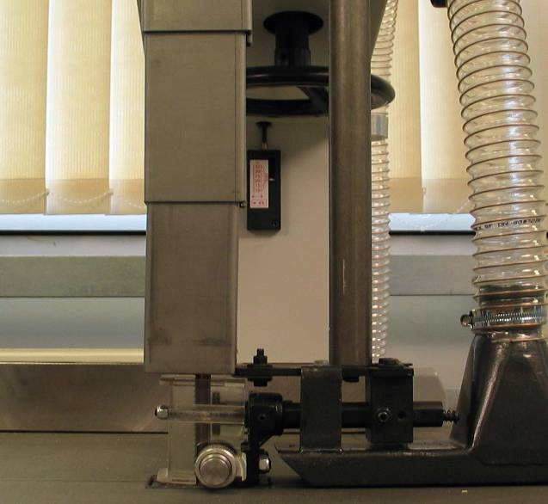
Telescopic
Blade Guard
Perspex
Blade Guard

5.4.2 The blade and the pulleys, controlling the speed and alignment of the blade, are located above and below the cutting table. Access is via doors which are fitted with micro switches. If the doors are opened while the blade is in motion the braked motor is triggered and the blade is brought to a complete stop within 10 seconds. (See Guards section 4.4.2)

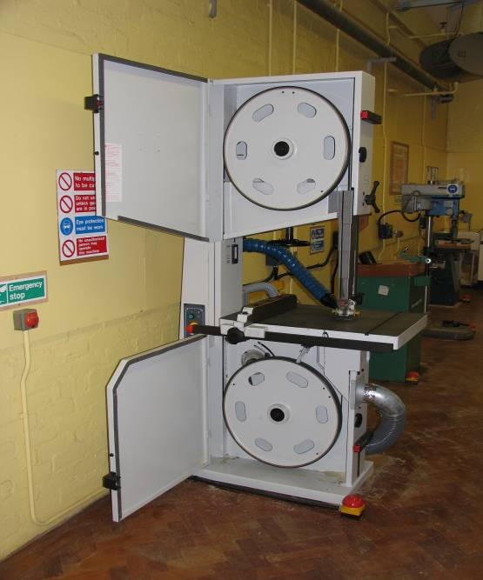
Pulley Wheels
Micro Switches
(Fitted to both doors)
Access Locking Cam
Wheels
(Fitted to both doors)

Adaptation

TSS staff have carried out the following adaptation: Access Locking Cam Wheels at the doors have been fitted with tamperproof screws that can only be removed by use of a tool.
It should be noted that the tamper proof screws must be removed to gain access to the pulley wheels. The full operation of the Locking Cam Wheel is deliberately restricted to prevent access prior to the machine coming to a complete stop.

5.5 Tension of the Blade
Before use, the tension of the blade should be checked at the Tension Gauge. The gauge should be set as follows: 12mm Blade – set at 12mm (between 10 and 15) the lower part of the pointer being the indicator.

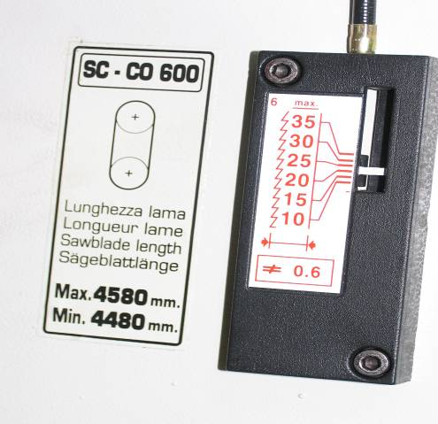
Tension Gauge
The tension of the blade should only be set and adjusted by technicians trained in safe use and maintenance of the bandsaw.

5.6 Table Block Insert
The passage of the blade is protected by the Table Block Insert, which is there to prevent the blade contacting the metal parts of the table. The serious of holes in the insert are there to assist the “under table” dust extraction.
Before use the Table Block Insert should be inspected for any damage. When as a consequence of being used, the passage slots get widened or chipped it has to be replaced.

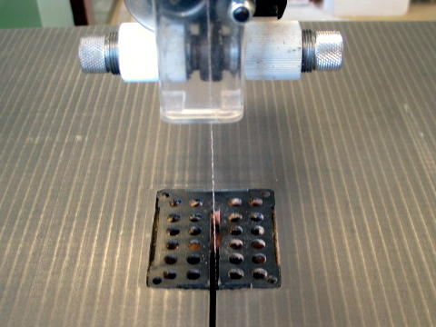
Table Block Insert
Replacement of the Table Block Insert should only be carried out by technicians trained in safe use and maintenance of the bandsaw.

5.7 Blade Guides

5.7.1 Before use, inspect the Blade Guide Thrust Wheel it should never come into direct contact with the back of the blade, but should be set at a distance of 0.75mm.

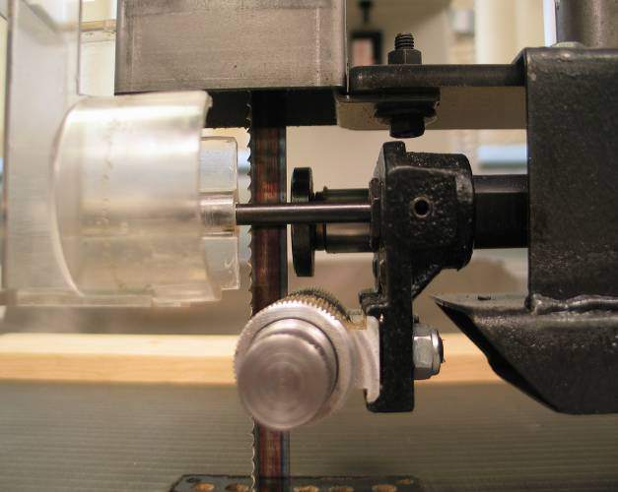
Blade Guide Thrust Wheel

5.7.2 The side wheels (Blade Guides) should be set just clear of the saw blade, the side wheels should rotate freely when the saw is in operation eliminating blade vibration.

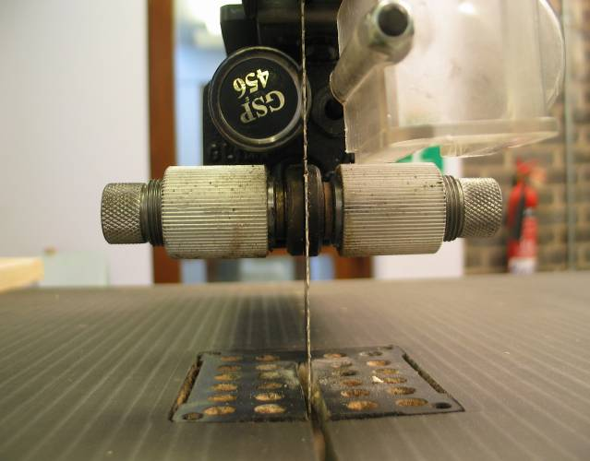
The Blade Guides and the Blade Guide Thrust Wheel should only be set and adjusted by technicians trained in safe use and maintenance of the bandsaw.
Blade Guides

Adaptation

TSS staff have carried out the following adaptation: The Blade Guide adjustment handles have been replaced with grub screws, to prevent inadvertent adjustment of the Blade Guides by unauthorised persons.

6 POWERING THE BANDSAW

6.1 Energise the Bandsaw

6.1.1 Switch on the 3-phase power supply to the work room, this may be controlled by a keyswitch

6.1.2 Switch the machine isolator to the “on” position

6.1.4 Remove the padlock from the Machine Power Panel at the rear of the machine and switch the power button to “on”

6.1.5 With the machine key in the keyswitch, switch to the “on” (1) position, the machine now has power, this is indicated by a red indicator light on the control panel
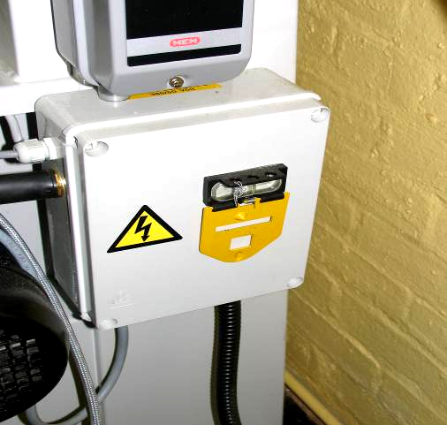
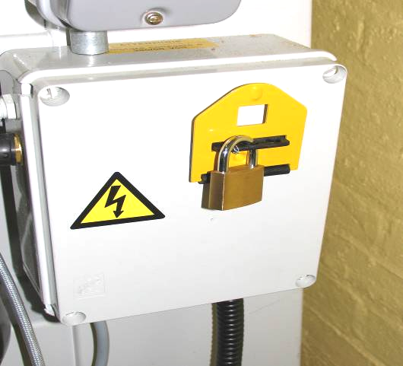

Machine Power Panel at the rear of the machine.

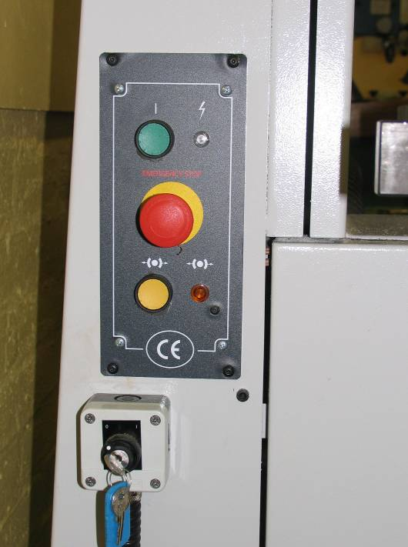
Red Stop Button
Keyswitch

Power Indicator
Start Button
Brake Release Control

Control Panel at the front of the machine.

6.2 Testing the Bandsaw Stopping Systems

6.2.1 Press the green start button, the machine will start and the blade will turn, press the Red Stop Button on the control panel, the Bandsaw will come to a complete stop in less than 10 seconds.

6.2.2 Reset the Red Stop Button: turn to the right to unlock and the button will reset.

6.2.3 Press the green start button, the machine will start, depress the Mushroom Headed Footstop, the Bandsaw will come to a complete stop in less than 10 seconds.

6.2.4 Reset the Mushroom-Headed Footstop by pulling the mushroom head out until you hear it “click” back into position.

The bandsaw is fitted with a Brake Release Control, which releases the brake from the pulley wheel. It should only be used when changing the blade or carrying out essential maintenance.

Only technicians trained in the safe use and maintenance of the bandsaw should change the blades or carry out essential maintenance.

When the bandsaw is operational, the Interlocked Extraction should automatically start. If this fails to happen – do not use the bandsaw – report this fault immediately to the appropriate Support Service Technician or Senior Support Service Technician.

The Mushroom-Headed Footstop is essentially part of the emergency stopping system and must not be routinely used as the stop button for the Bandsaw.

The Emergency Stopping Systems will be tested regularly by the Support Service Technicians as part of the routine maintenance of the machine tools.

The bandsaw is now ready for use.

7 PREPARING THE BANDSAW FOR USE
Ensure that the bandsaw is isolated from the power supply and brought to a complete stop before making adjustments.

7.1 Fence Guide
The Fence Guide needs to be used when making parallel cuts. In addition, it is to be used to cut thick pieces for which there is a danger of tilting over sideways.

7.1.1 Measure the distance from the inside face of the Fence Guide to the edge of the blade, for the required length to be cut.

7.1.2 The Fence Guide is adjusted by sliding the fence along the Fence Guide Bar and is locked in position using the Fence Guide Locking Handle.
Fence Guide
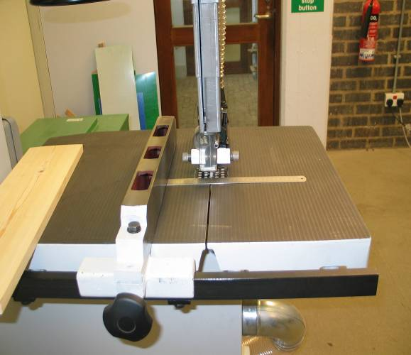
Fence Guide Locking
Handle
Fence Guide Bar

7.2 Adjusting the Blade Guard

7.2.1 With the Perspex guard in position and locked

7.2.2 Release the Telescopic Blade Guard by unlocking at the Blade Guard Locking Handle

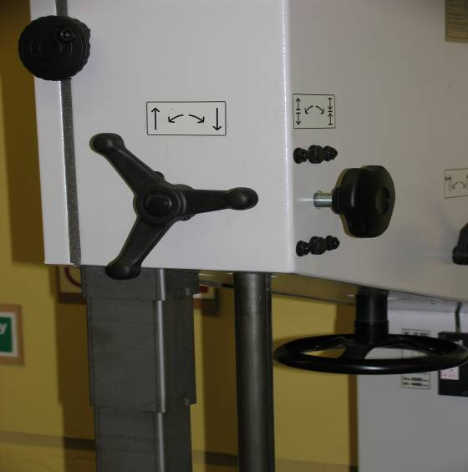
Blade Guard
Adjustment
Handle
Blade Guard
Locking Handle

7.2.3 Raise / lower the Telescopic Blade Guard by turning the Blade Guard Adjustment Handle

7.2.4 Set the guard to a distance of about 3mm-5mm above the workpeice when cutting with a guide (see Cutting section – 9.1))

7.2.5 When cutting without a guide the maximum distance for the Perspex Guard to be set above the workpeice is 23mm (as recommended in the users manual), this is to allow the operator a clear view of the blade (See Cutting section 9.2/9.3)

7.2.6 Now lock the Telescopic Blade Guard in position using the Blade Guard Locking Handle

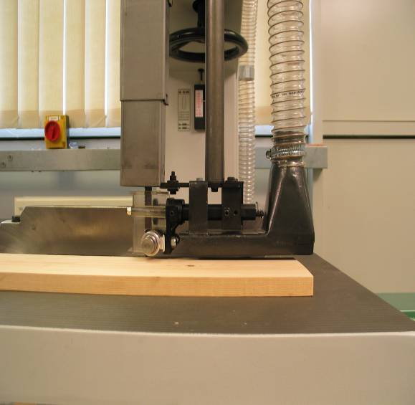

8 FEEDING MATERIAL THROUGH THE BANDSAW

It is essential when cutting, to ensure that hands are correctly positioned and kept clear of the area immediately around the saw blade. Push Sticks are used to avoid hands coming close to the moving blade.

8.1 Push Sticks

8.1.1 Are used to safely feed the material through the blade, keeping hands at a safe distance

8.1.2 After the Bandsaw has been stopped, Push Sticks should be used to remove debris from the area around the blade and off the cutting table

8.1.3 Push Sticks must be used when the Fence Guide is in use

The Centauro Bandsaw is supplied with a plastic Push Stick. Support Service Technicians can make Push Sticks for use as required, TSS recommend that Push Sticks be a minimum of 450mm in length with a “bird’s mouth” in line with the guidance provided by the HSE regarding the use of Push Sticks with Circular Sawing Machines.

8.2 Feed Speed
It is essential to feed the material being cut through the bandsaw at a steady speed, by applying an even pressure to the workpeice. The speed of the cut is determined by the type of material being fed through. If the material is forced through the blade too fast, the blade will be pushed back against the “Thrust Wheel” the noise level of the saw will increase, the workpeice can jam and the blade may be damaged.
Should the workpeice jam in the blade, gently but firmly pull the workpeice back out of the blade. If the workpeice remains jammed, switch off the power, isolate and lock-off the bandsaw and inform the appropriate Support Service Technician or the Senior Support Service Technician.

8.3 Take-off
The bandsaw is designed to be used by only one person at a time, there should never be anyone positioned at the back of the bandsaw assisting in “taking-off” materials. Only “push sticks” should be used to assist in pushing materials through the blade and/or off the table

8.4 Blades
The Centauro Bandsaw is supplied fitted with a 25mm blade; this blade is essentially for rough cutting and is limited in the type and depth of material it can be used to cut. A 12mm blade is also supplied with each bandsaw; this is a general purpose blade and can be used to cut the full range of materials used in schools.

9 CUTTING MATERIAL

9.1 Cutting with the Fence Guide Using a “Push Stick”

9.1.1 Ensure that the bandsaw is isolated before making any adjustments

9.1.2 With the Fence Guide already set, position the workpeice along the side of the Fence Guide, ready for cutting

9.1.3 Set the Blade Guards at a distance of 3mm-5mm above the workpeice

9.1.4 Push Sticks must be used to feed the workpeice through when using the Fence Guide

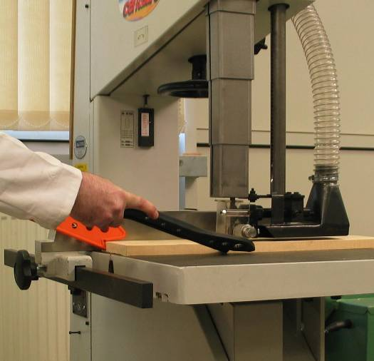

9.2 Cutting without the Fence Guide Using a “Push Stick”

9.2.1 Ensure that the bandsaw is isolated before making any adjustments

9.2.2 The workpeice should be clearly marked with a pencil or scribe, where to be cut

9.2.3 The Blade Guards should be set at a maximum distance of 23mm above the workpeice, to allow the operator clear sight of the blade as advised in the users manual

9.2.4 Hands should be safely positioned and fingers should be kept clear of the cutting line

9.2.5 The workpeice should be fed through the bandsaw along the cutting line and through the other side using the Push Stick

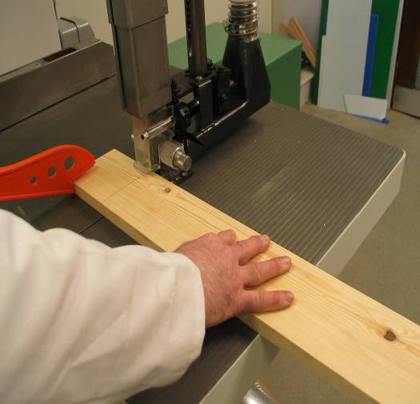

9.3 Cutting without the Fence Guide (Free Hand)

9.3.1 Ensure that the bandsaw is isolated before making any adjustments

9.3.2 The Blade Guards should be set at a maximum distance of 23mm above the workpeice, to enable the operator clear sight of the blade as advised in the users manual

9.3.3 Hands should be safely positioned and fingers should be kept clear of the cutting line

9.3.4 The workpeice should be fed through the bandsaw, ensuring that the operators fingers and thumbs are always kept at a safe distance from the blade

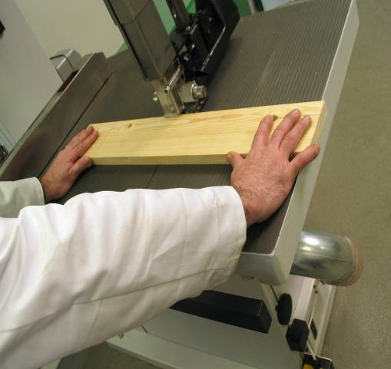

9.4 Cutting at an Angle – Using the Tilt Mechanism
This facility is not available on the Centauro Bandsaw, although referred to in the instruction manual. Staff are advised not to attempt angled cuts using the tilt mechanism.

Bandsaw cutting using the tilt mechanism not permitted.

Adaptation
TSS staff have carried out the following adaptation: A caphead bolt has been fitted, and secured by means of Loctite Threadlock, to the tilt mechanism at the rear of the bandsaw. This screw is in addition to the screw already fitted; its purpose is to prevent use of the tilt mechanism.

9.5 Curved and Irregular Cuts
The Centauro Bandsaw can be used with or without a template to cut curves or irregular shapes. Blades can be damaged by “rubbing / binding” on material if used to cut a radius too small. Therefore, when used to cut circles the radius of the circle is limited by the width of the blade as follows:

Width of Bandsaw Blade | Minimum Radius of Circle
10mm | 37mm
12mm | 75mm
25mm | 200mm

Cutting curves, irregular shapes and circles is carried out with or without the aid of push sticks, it is therefore important that hands are safely positioned and fingers and thumbs are always kept at a safe distance from the blade.

9.6 False Fence
Technician Support Services in consultation with the technicians and manufacturers have designed and developed a suitable false fence for use with the Centauro Bandsaw.

NOTE: Operators must never leave the bandsaw unattended while the blade is running.

10 POWER DOWN THE BANDSAW

10.1 Press the red Stop Button on the control panel to stop the bandsaw, the blade should come to a complete stop within 10 seconds

10.2 Turn the Keyswitch to the off (0) position and remove the key

10.3 When finished using the machine for the day, switch off the power to the bandsaw, at the Power Panel at the rear of the machine, replace the padlock

10.4 Switch off the bandsaw isolator

NOTE: Operators must never leave the Bandsaw, after use, so that it can be readily “powered up” and used by unauthorised users.

11 LEAVING THE BANDSAW SAFE FOR THE NEXT USER

11.1 Clear the bandsaw table of all debris and dust, using the Hepa filter Vacuum Cleaner as appropriate

11.2 If the Fence Guide was used, return it to the left hand side of the machine and lock in place

11.3 Lower the Telescopic Blade Guard to its lowest position on the table and lock the Blade Guard in place, so as to leave the blade fully guarded

12 FAULT REPORTING

12.1 If any fault or damage is found when using the bandsaw, or if the blade breaks the user should:

12.1.1 Switch off the bandsaw

12.1.2 Isolate the bandsaw and lock off the power using the padlock

12.1.3 Report any faults, defects or damage immediately to the appropriate Support Service Technician or the Senior Support Service Technician, who will arrange for any necessary maintenance or repairs to be carried out

12.2 If any fault or damage to the bandsaw is reported, the following action should be taken by the appropriate Support Service Technician:

12.2.1 Ensure that the bandsaw has been isolated from the power supply and that the power is locked off using the padlock

12.2.2 Attach a padlock to the bandsaw isolator and retain the key

12.2.3 Label the bandsaw “Do Not Use – Under Repair”

12.2.4 Advise the necessary staff that the bandsaw cannot be used

12.2.5 If appropriate carry out necessary repair or maintenance

12.2.6 If necessary contact TSS to arrange for repair

13 REFERENCE MATERIAL
This document was compiled with reference made to the following material:

- BS 4163:2000 Health and Safety for Design and Technology in Schools and similar establishments – Code of Practice
- Centauro Compact Bandsaw – Spare parts and instructions booklet (5th edition)
- The Design and Technology Association (DATA) – A Guide for Consultants, Trainers and Teachers for Health and Safety Training
- Technical Education – A Code of Practice 1995
- Technician Support Service – Training Material

