


Technician Guidance Sheets
TGS / 06

Safety Signs required for Fixed Machine Tools in Technical Departments

Issued by Technician Support Service

Date June 2007

Objectives - The objective of this guidance sheet is to provide a list of the safety signs required to be appropriately displayed at specific fixed machine tools within the technical department.

Persons responsible – Senior Support Service Technician and Support Service Technicians

WOOD MACHINES
Bandsaw | 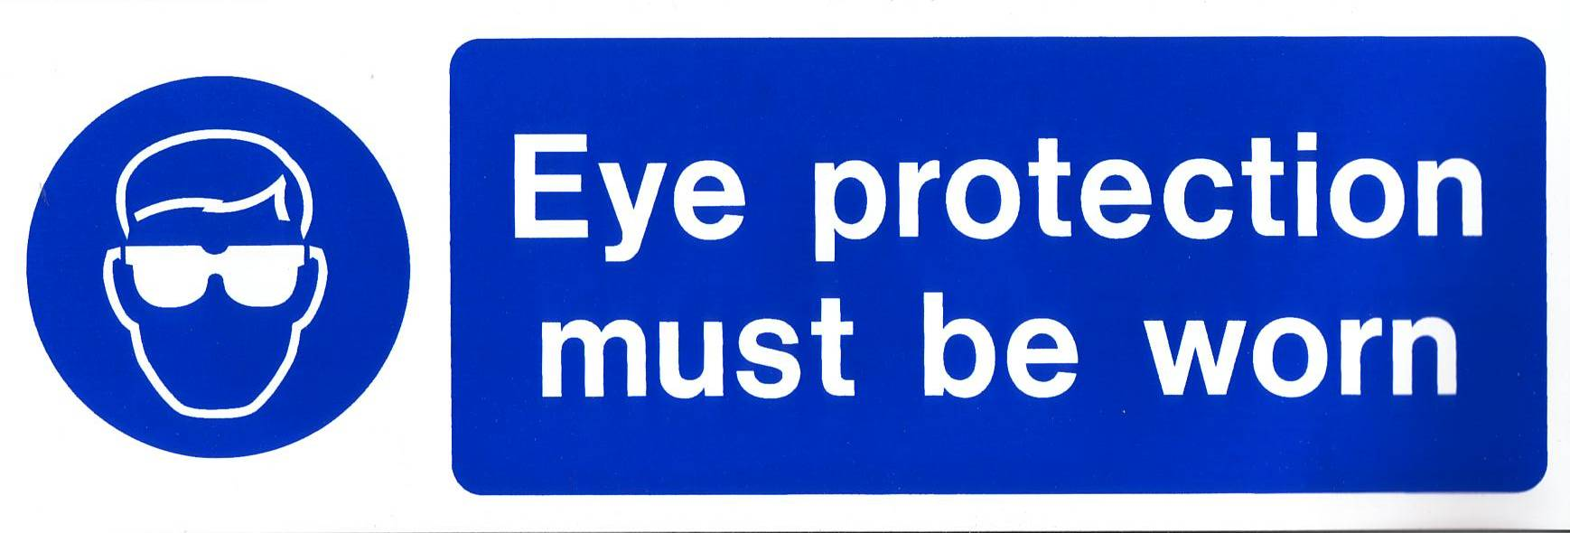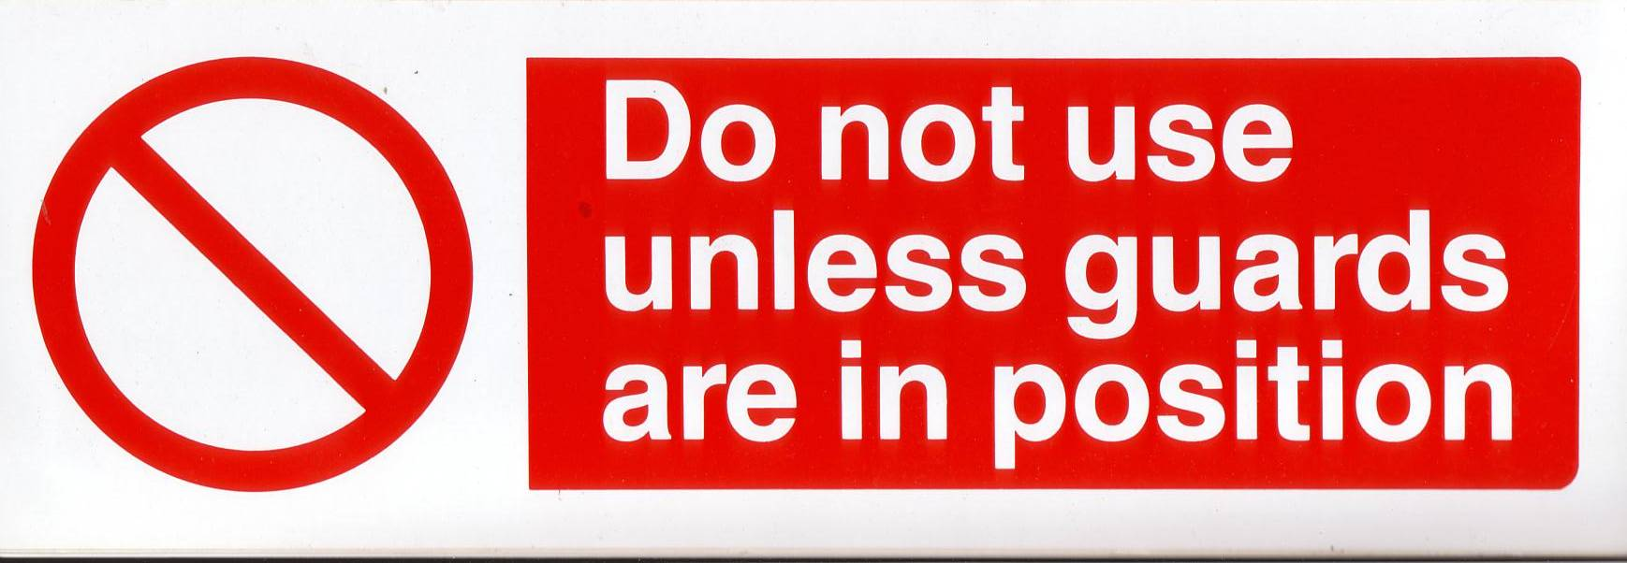  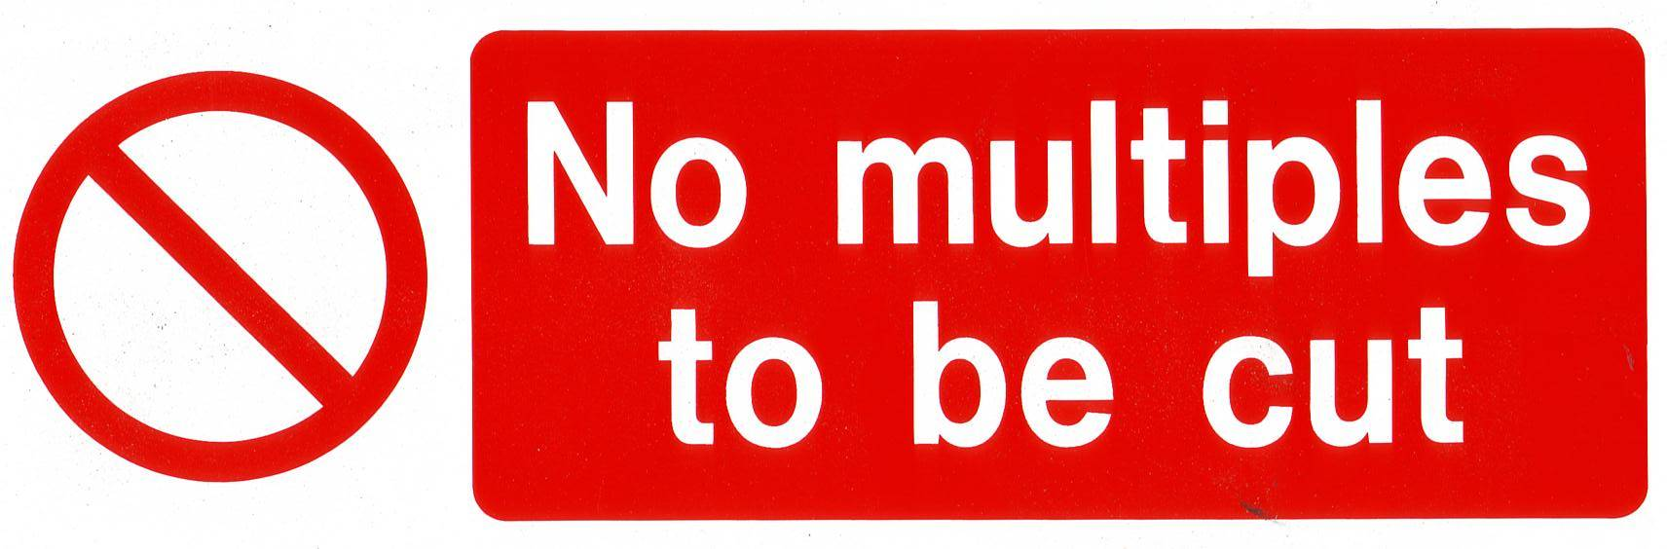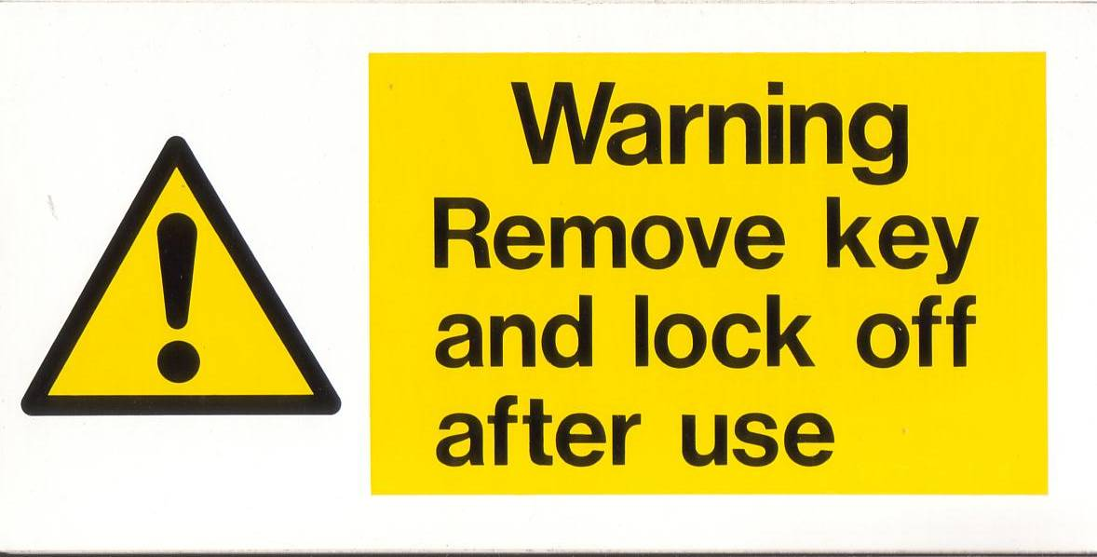
Belt and Disc Sander | 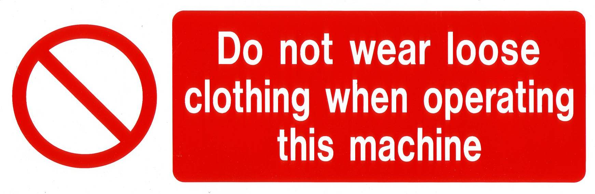  
Circular Saw | 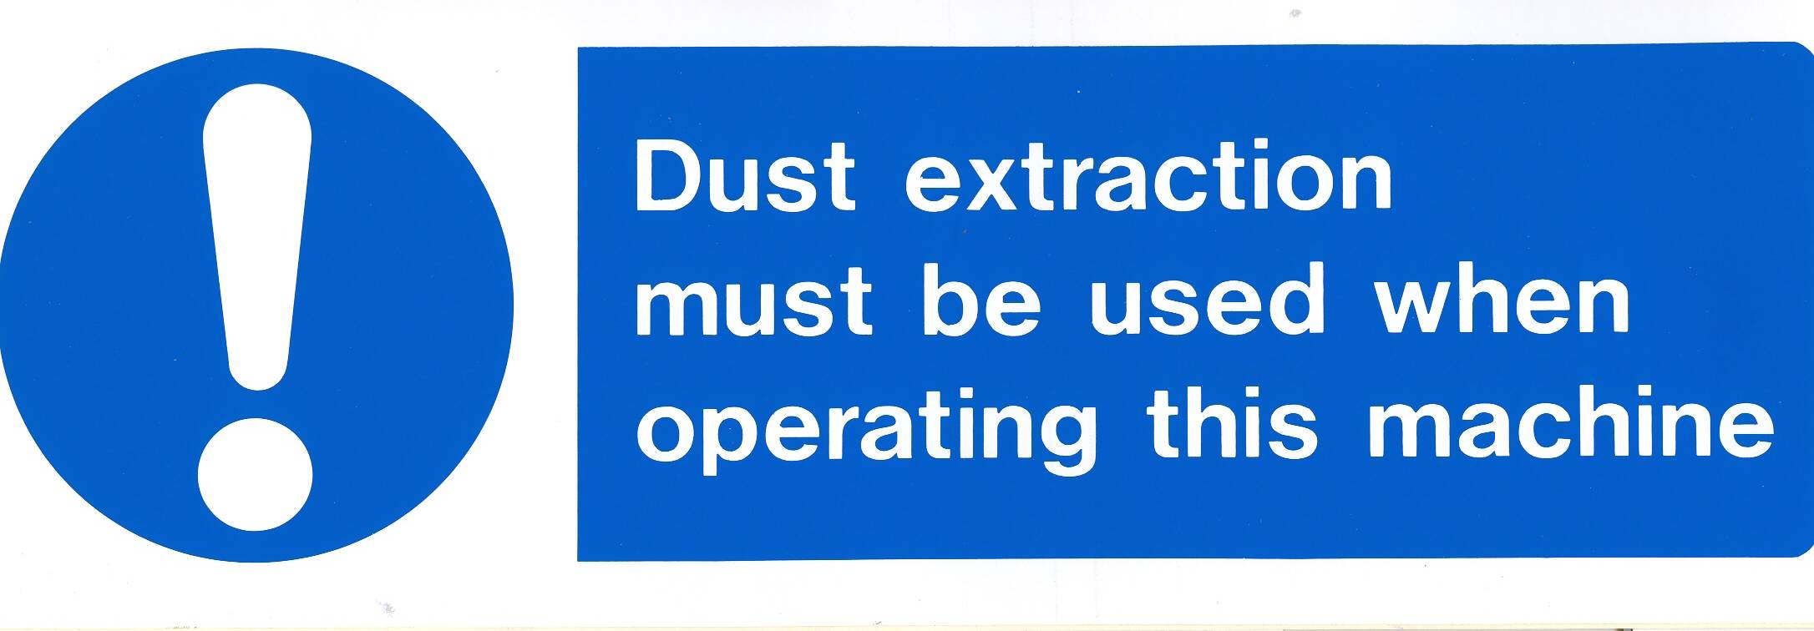  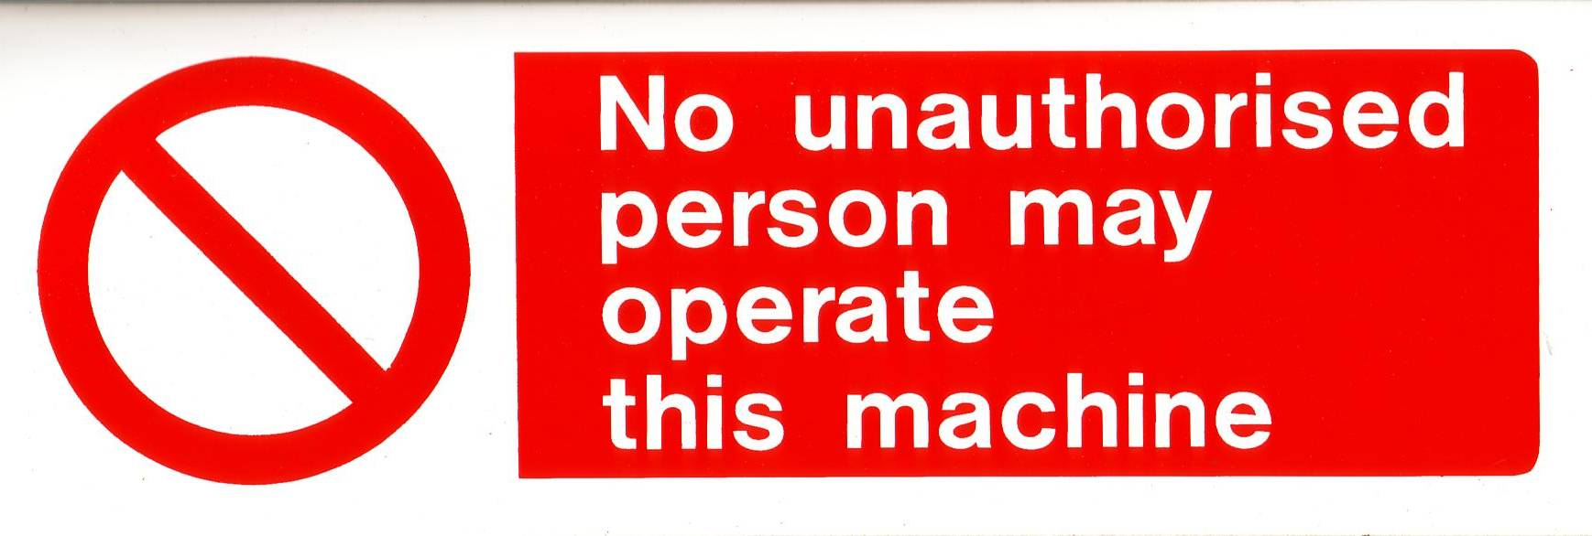  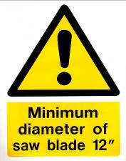
Fretsaw

Planer/Thicknesser

Mortise Machine

Vertical Drilling
Machine
(Bench / Pedestal)

Wood Turning Lathe

Additional signs | 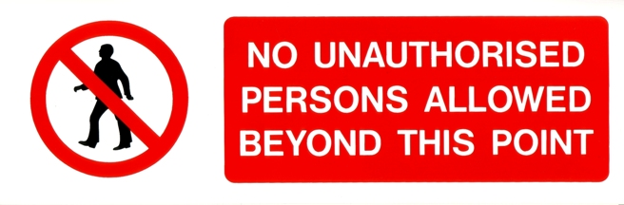    These signs should be displayed on the entrance door to the room where the circular saw and planer thicknesser are located.    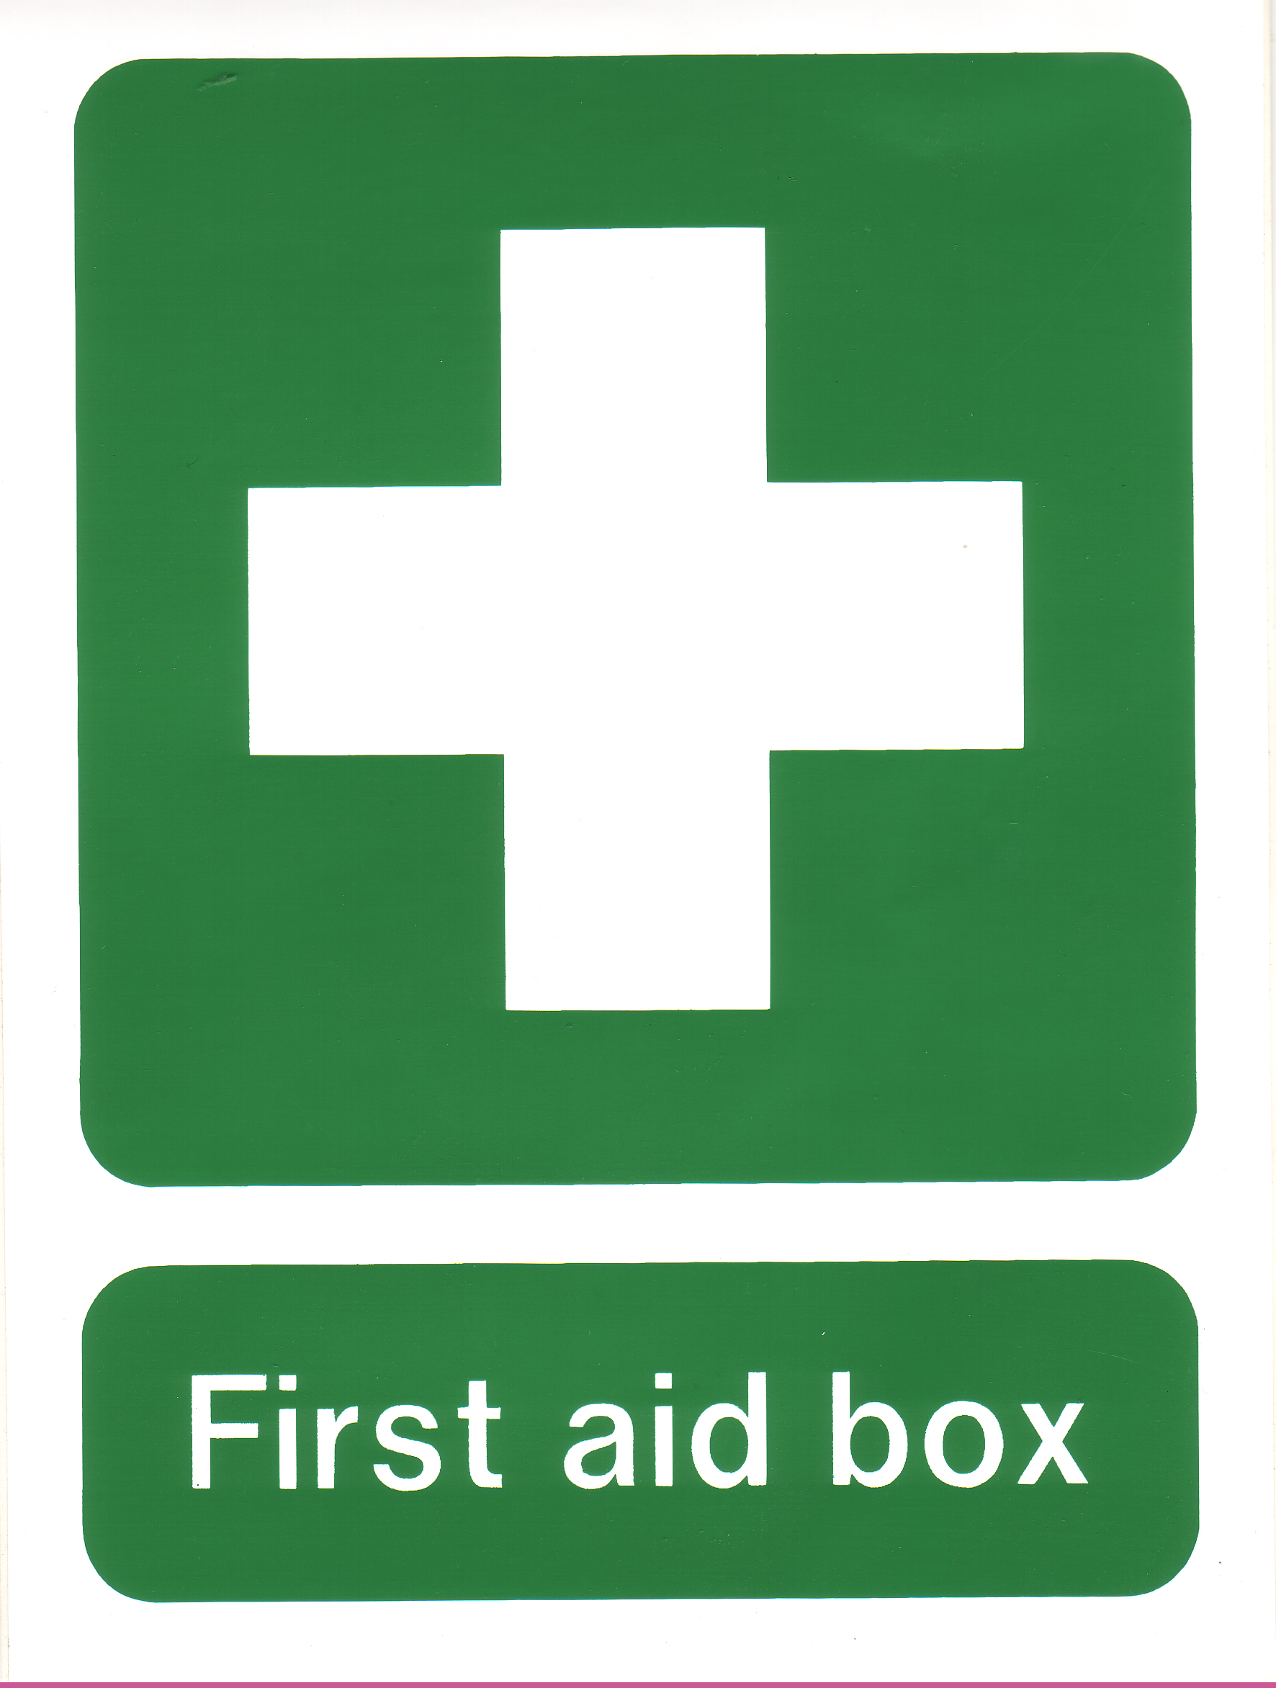

METAL
MACHINES
Grinder  (Double Ended) | 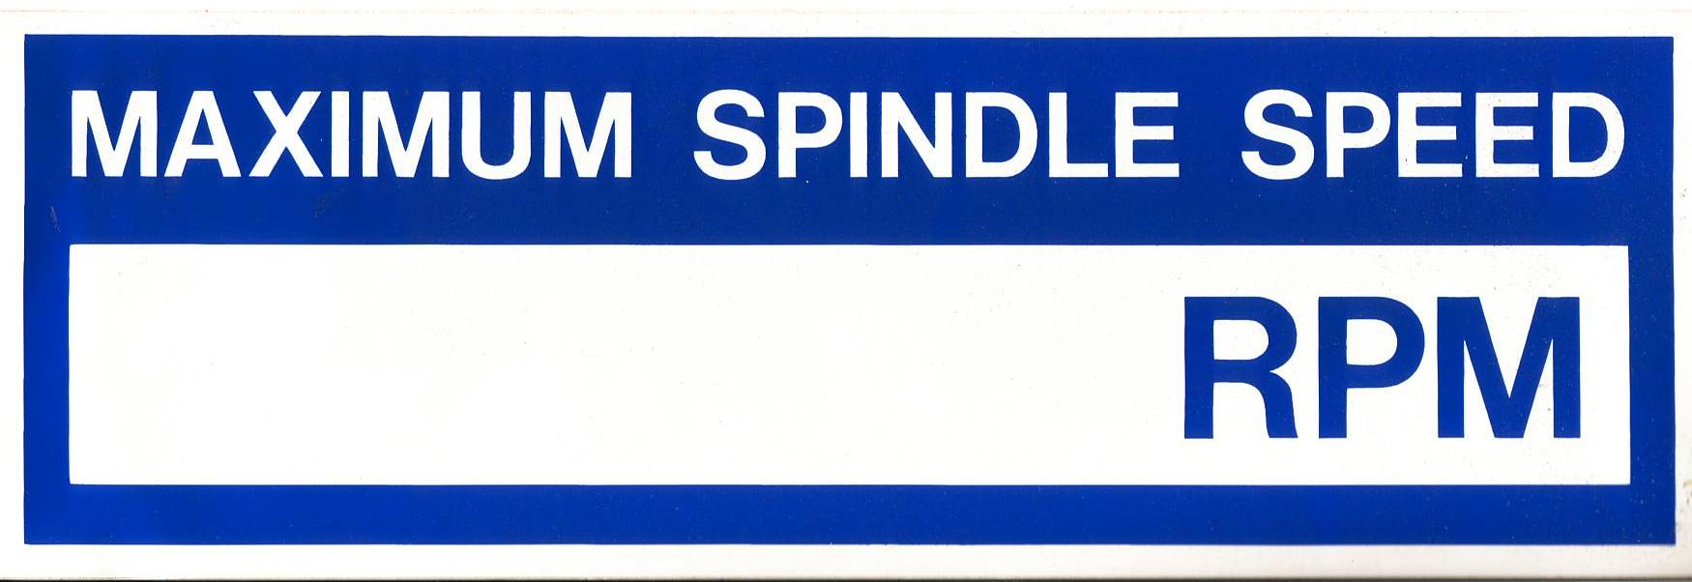
Polisher
(Double Ended)

Guillotine / Notcher | 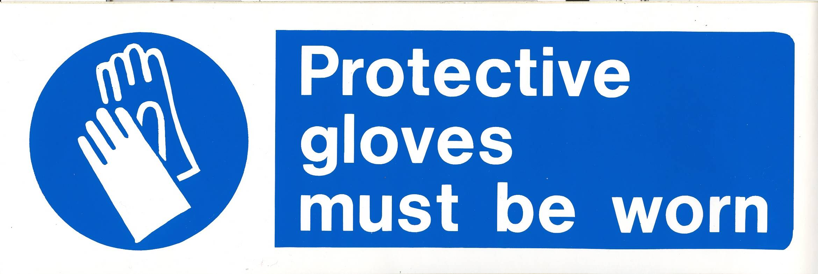
Linisher

Metal Turning Lathe

Power Hacksaw

Sharpedge Grinder

HOT PROCESS
MACHINES
Ceramic Chip Forge |   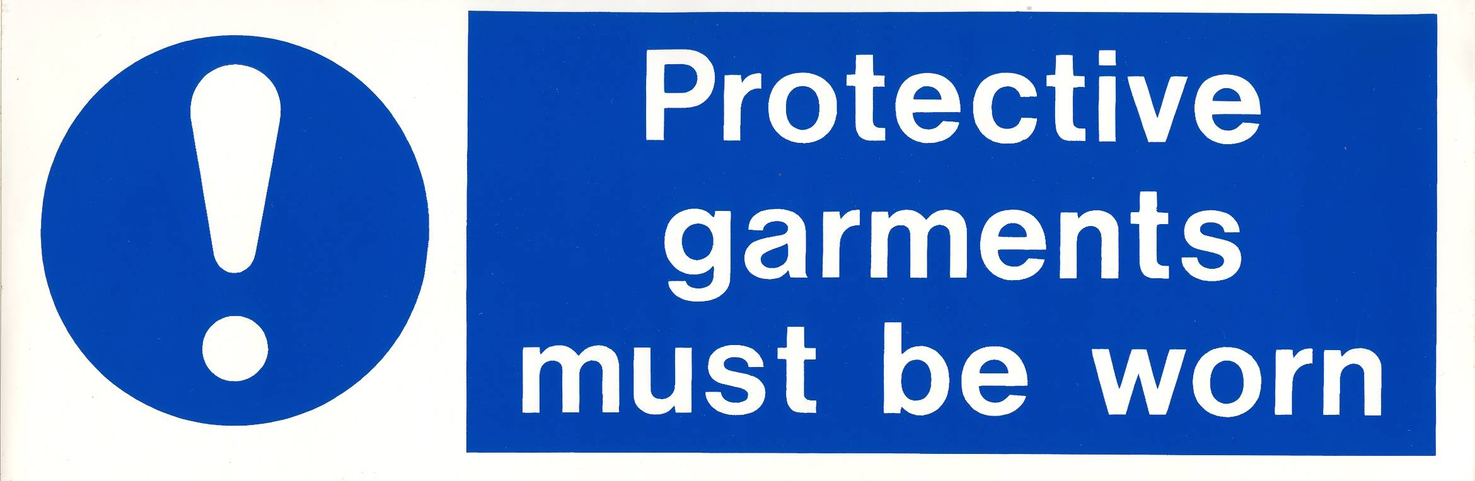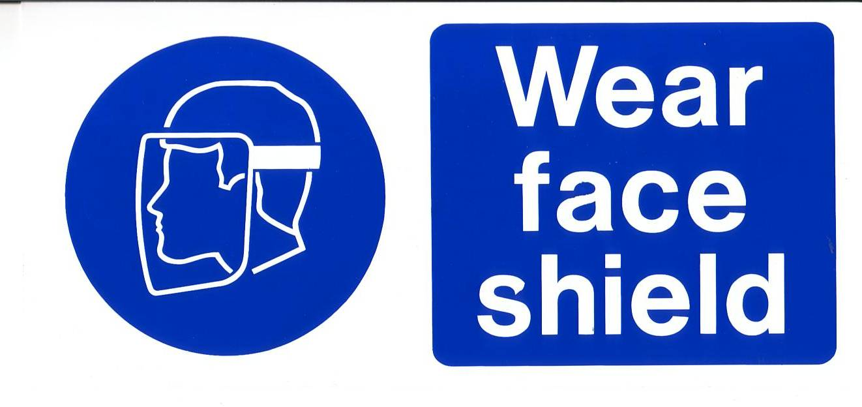  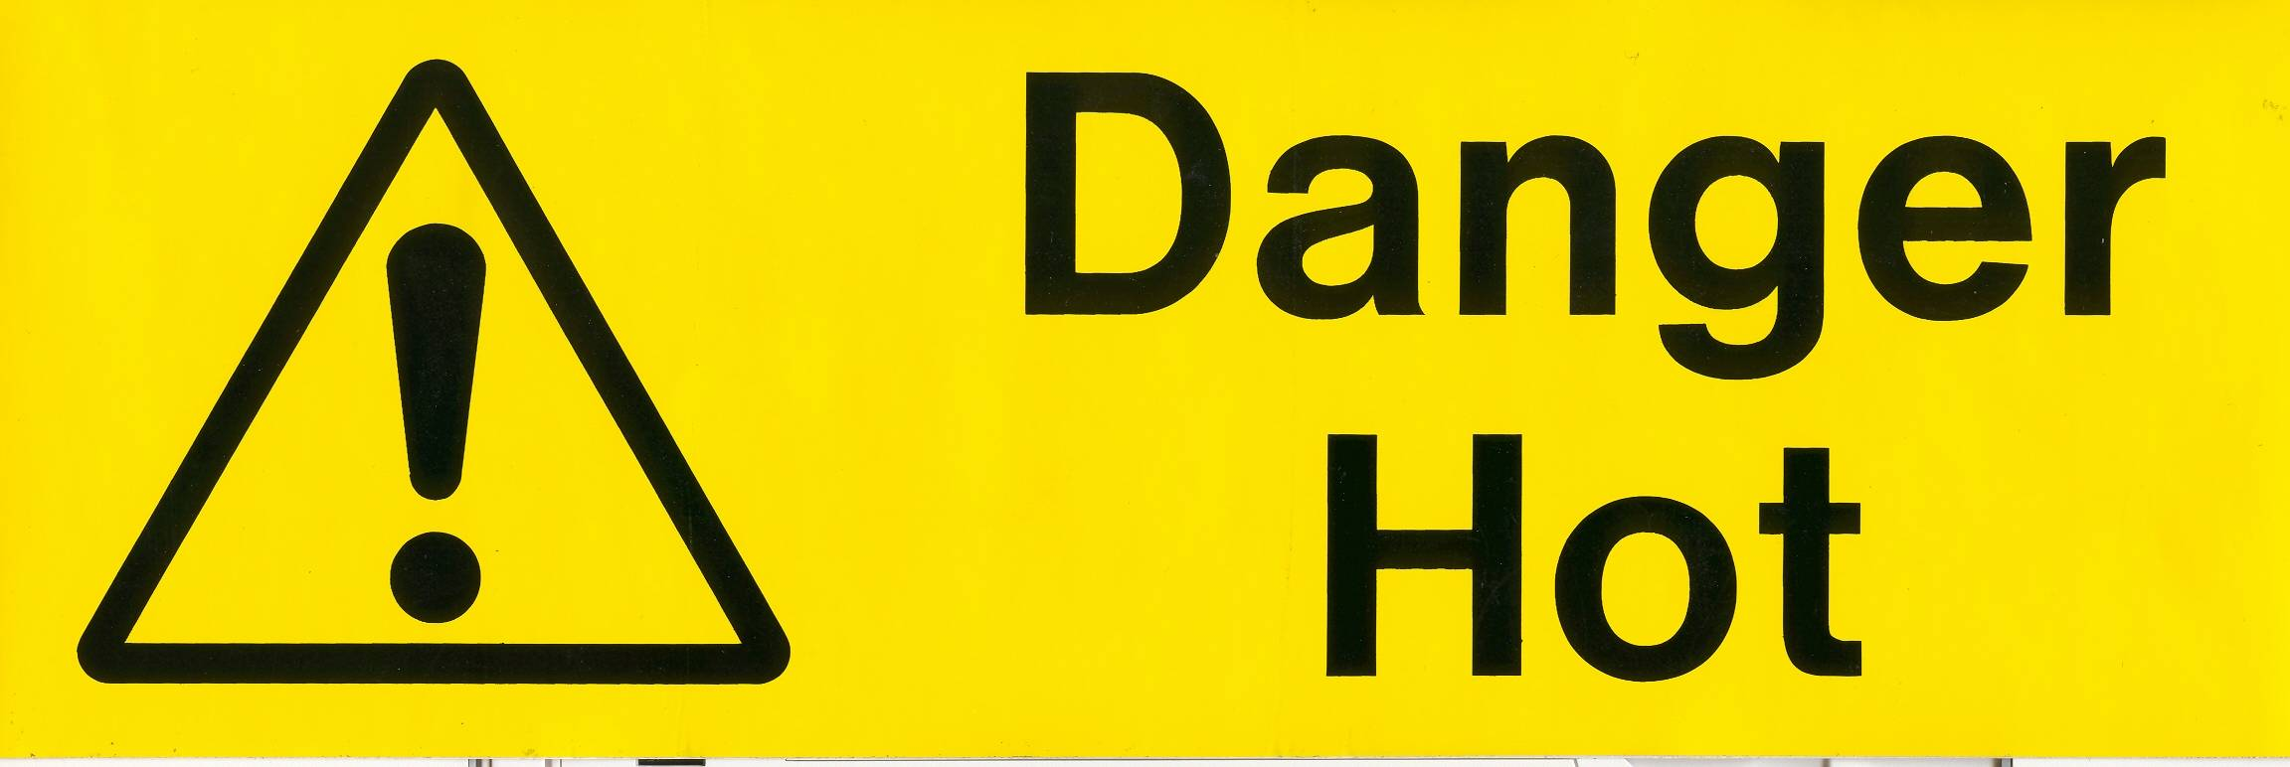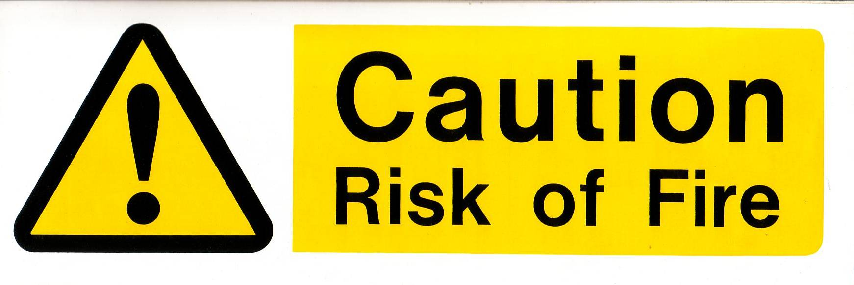
Crucible

Arc Welder | 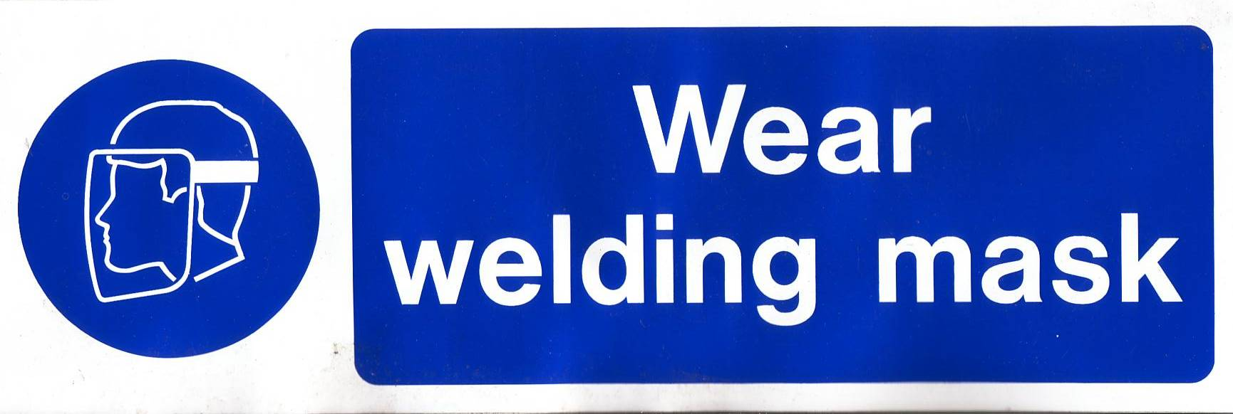  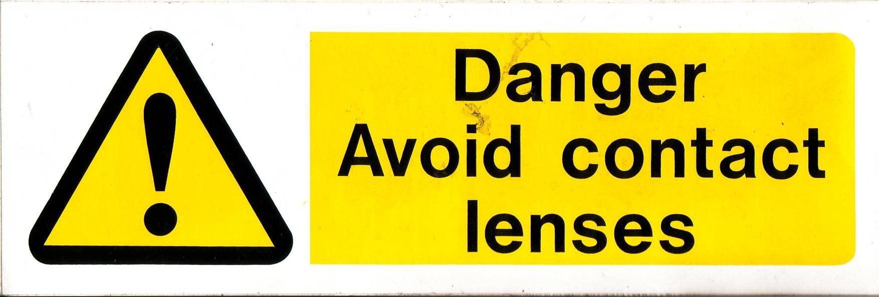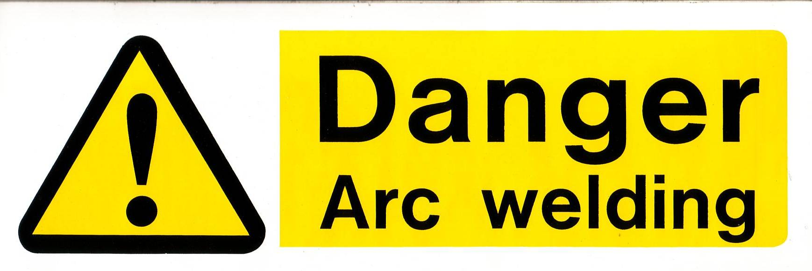
Spot Welder

Mig Welder | 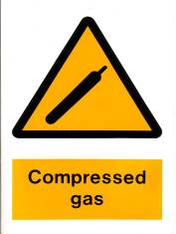  The “compressed gas” sign should be displayed on the door of the workroom in which the gas cylinder is being used and permanently displayed on the door of the room in which the gas cylinder is stored (if different).

Technical Machines Safety Signs – Key Code for ordering from TRS
MB01 | MB02 | MB03
MB04 | MB05 | MB06
MB07 | MB08 | MB09


MB10
WY01 | WY02 | WY03
WY04 | WY05 | WY06
 |  | 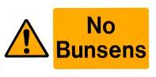
WY07 | WY08 | WY09
PR01 | PR02 | PR03
PR04 | PR05
SC01 | SC02

