


Technician Guidance Sheets TGS / 21

Safe Use: Ambassador Pedestal Drilling Machine
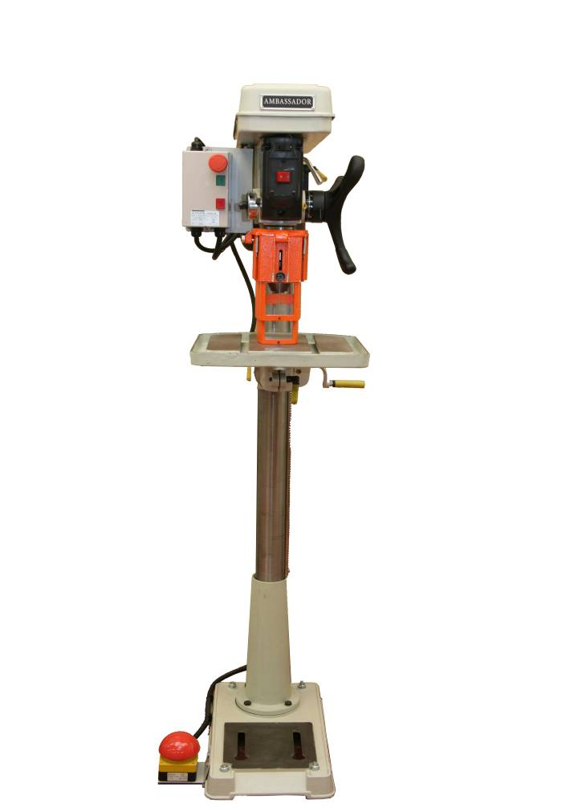

Issued by Technician Support Service

Date February 2011

Objectives - The objectives of this guidance sheet are to ensure the safe use of the Ambassador Pedestal / Bench Drill and to highlight the functional changes in the new machines when compared to previous models used in secondary schools.

Persons responsible – School Technicians and Technical Teaching Staff

Safe Use: Ambassador Drill Index
1 |  | Aims and Objectives | 2 - 3
 |  | Ambassador Drill – labelled diagram | 4
2 |  | Usage | 5
3 |  | Hazards | 5
4 |  | Control Measures | 5 – 6
5 |  | Safety Checks Before Use:
 | 5.1 | Clear Working Area around the Ambassador Drill | 6
 | 5.2 | Ensure the Ambassador Drill is isolated | 6
 | 5.3 | Drill Speed | 6
6 |  | Adjusting the Spindle Speed | 7 - 8
7 |  | Powering the Ambassador Drill:
 | 7.1 | Energise the Ambassador Drill | 9
 | 7.2 | Testing the Ambassador Drill Stopping Systems | 9 - 10
8 |  | Securing Material for Drilling:
 | 8.1 | Clamps | 10
 | 8.2 | Vice | 11
 | 8.3 | Clamping Jig | 12
9 |  | Preparation of the Drill for Use:
 | 9.1 | Selecting the Correct Cutter | 13 - 15
 | 9.2 | Local Restrictions | 15
 | 9.3 | Selecting the Correct Drill Speed | 15
 | 9.4 | Take - Off | 15
10 |  | Cutting Material
 | 10.1 | Using the Depth Stop | 16
 | 10.2 | Feed Speed | 17
 | 10.3 | Swarf / Wood Chippings | 17
11 |  | Power Down the Ambassador Drill | 18
12 |  | Leaving the Ambassador Drill Safe for the Next User | 18
13 |  | Fault Reporting | 18
14 |  | Reference Material | 19
 |  | Drill Press Speed Chart – Appendix A | 20

Safe Operation of the Ambassador Drill

AIMS AND OBJECTIVES

Aims
To instruct teaching and technician staff in the safe use of the Ambassador Drill and to highlight and demonstrate any functional changes in the new machines.

General Objectives

To outline the safety precautions necessary for the safe operation of the drill.

To demonstrate the functions of the guards and safety devices.

To demonstrate how to set the tools and prepare the drill for safe use.

To demonstrate how to operate the drill to carry out its functions safely.

To highlight any modifications Technician Support Service have made to the drill.

Specific Objectives

Know and understand the hazards associated with use of the drill.

Know, observe and follow the advice of the safety signs which apply to the drill.

Know what personal protective equipment (PPE) is mandatory when using the drill.

Become familiar with the parts of the drill and their functions.

Know and implement the guarding requirements of the drill.

Be able to position and adjust the guards correctly.

Ensure that the drive/belt mechanism access is locked.

Know that the drill must be electrically isolated before making any adjustments or cleaning.

Be aware of the materials that can and cannot be drilled.

Know not to attempt to drill multiples of materials.

Be aware of the location and function of the emergency stops.

Become familiar with the “power up” procedures for the drill.

Know and adopt the correct position/stance when using the drill.

Understand the use of vices and clamps for a workpiece and when to use them.

Know when to feed the drill / cutter into the material with firm and steady pressure and when to adopt a stepped drilling procedure.

Become familiar with the “power down” procedures and isolation of the drill.

Know to leave the drill clean, tidy and in a safe condition when work is completed.

Know to never leave a drill unattended when the machine is running.

Know to report any damage or faults immediately and be aware of the reporting procedures.

Ambassador Pedestal Drill
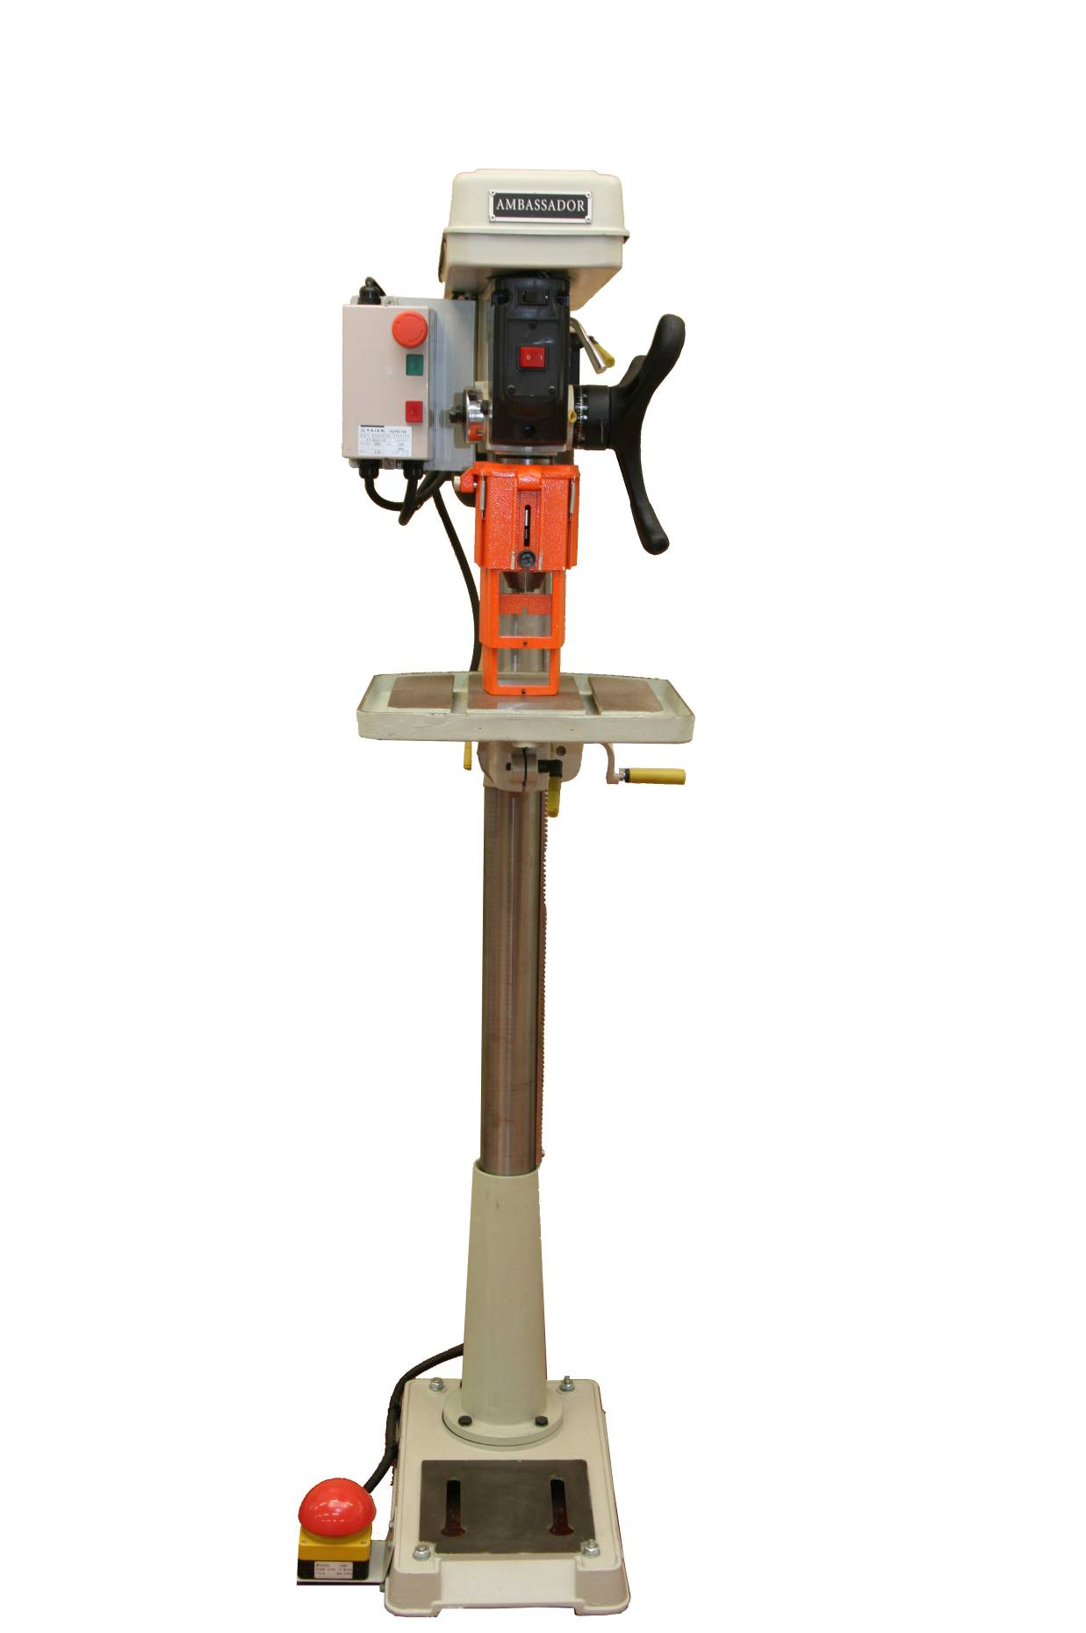
Belt Guard
Drill NVR Switch
Light Switch
(for integral lamp)

Table Lock
Feed Spring / Cap
Feed Wheel
Depth Scale / Lock
Table
Column
Rack
Belt Tension / Locking Handles
Table Crank
Base
Column Support
Table Support / Lock
Adjustable Drill Guard
Chuck Assembly
Emergency Footstop
Start / Stop Controls
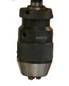

USAGE
Softwood, hardwood, composite materials, plastics and metal.

HAZARDS

Work pieces jamming, spinning can cause hand injuries

Electric shock

Drill bit breaking, swarf can be ejected into the room

Sharp edges on drill, work pieces and swarf can cause cuts

Hands and fingers can contact the drill, gearing and pulleys

Entanglement: clothing, long hair and loose jewellery can become entangled

Environmental: keep area around machinery clear of surplus materials, wood waste and other tripping or slipping hazards

Inadvertent starting/stopping of the machine

Unauthorised persons using the machine

CONTROL MEASURES

Safety Signs
Blue – Mandatory Instructions Red – Prohibatory Yellow - Warning





Personal Protective Equipment (PPE)

Goggles (BSEN-166-349B)

Loose clothing must be secured and long hair tied back

Emergency Stop Systems

Room Emergency Stop System – various sites around the room

Mushroom Headed Footstop – situated at the base of the drill

Guards
HSE: Drilling machines: guarding of spindles and attachments – Guidance Note PM3

12 “Effective guarding of spindles and chucks presents no real difficulty. It is often claimed that guarding of the drill itself is impracticable because it would obstruct the view of the workpiece, slow down the process of changing drills, or otherwise interfere with production. However, most accidents occur at the tip of the drill when it is in its topmost position and the operator is removing the drilled workpiece or securing the next. Guarding is therefore necessary and, with careful design, can provide a high standard of protection without interfering with production.”

16 ”During drilling work it is essential that the guard should be below the tip of the drill when it is in its raised position.”

25 ” Drive mechanisms of drilling machines can be dangerous. Where access is infrequent (e.g. for maintenance), only a fixed guard or cover plate requiring a tool for its removal should be fitted. If access is regular (e.g. for changing speed by means of a multi-step pulley and belt), then the guards or cover should electrically interlock the power to the motor driving the pulley.”

Guard – Silvaflame fully adjustable telescopic guard; secured to the depth stop collar with an integral clamp. It is aluminium in construction with 2 polycarbonate visor sections which allow visibility for the operator and telescope on contact with the workpiece, guarding all rotating parts during all stages of the drilling process – from fully raised to fully lowered.

Belt Guard – This is a fixed guard restricting access to the drive belts and pulleys. The guard has a micro switch fitted which cuts the power to the motor when the guard is open. It is fixed using tamperproof screws and should only be removed to adjust or replace the drive belts or alter the speed of the drill. Only competent technicians and technical teaching staff trained in this process should access this area.

SAFETY CHECKS BEFORE USE

Clear Working Area around the Ambassador Drill
Before use, ensure that the area around the drill is clear of surplus waste materials, wood waste products and / or models that may hinder the safe use of the drill.

Ensure the Ambassador Drill is Isolated
Before carrying out any safety checks the drill must be isolated from the power supply. Check the machine isolator is in the “off” position.

Drill Speed
The correct spindle speed must be selected and set before operating the Drill. To calculate the spindle speed required the following factors should be considered:

Type of material being drilled (plastic, metal, wood, hard, soft, thick, thin etc.)

Type of drill / cutter to be used

Size of hole to be cut

ADJUSTING THE SPINDLE SPEED

The Ambassador Drill is controlled by 2 drive belts and 3 sets of pulley wheels and can be adjusted to 12 different speeds ranging from 180 RPM to 2740 RPM. The positioning of the drive belts on the pulleys determines the speed of the spindle as shown below. This diagram can be found on the underside of the belt guard.

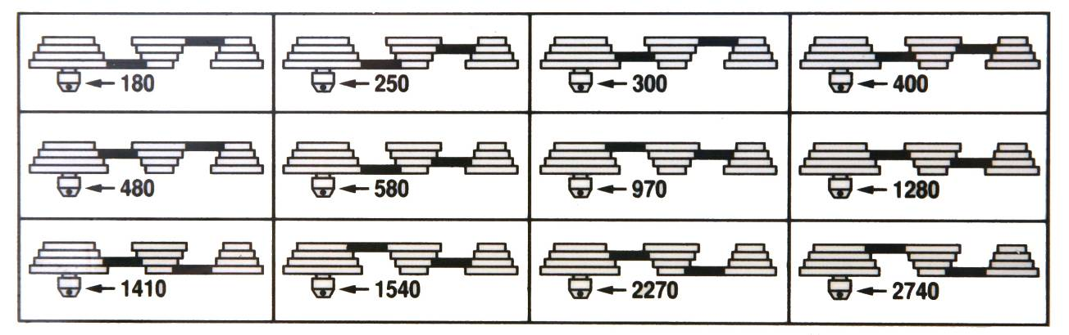

Spindle Speed Information

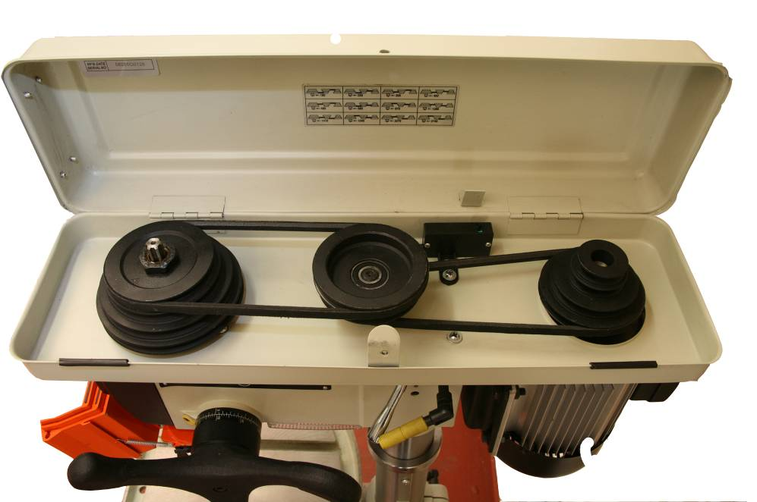
Motor Pulley
Drive Belts (x2)
Drive Belt
Locking Handle
(1 on each side of the drill)

Spindle Pulley
Middle Pulley
Drive Belt
Tension Lever

To change the spindle speed work as follows:

Ensure that the drill is isolated from the power supply and that the power isolator is locked – off with the yellow maintenance padlock, retain the key.

Remove the tamperproof screw from the belt guard and open to expose the drive belts and pulleys.

Select the required speed from the information on the inside of the guard.

Loosen the drive belt locking handles located on each side of the machine head.

Release the tension on the belts by pulling the tension lever forward (toward the front of the machine).

Position the drive belts on the pulleys as advised by the information guide.

Re-tension the drive belts by pushing the tension lever back (toward the back of the machine) until the desired tension is reached.

Lock the drive belts in position using the locking handles.

Close the belt guard and replace the tamperproof screw.

Remove the padlock from the isolator and energise the machine.

POWERING THE AMBASSADOR DRILL

Energise the Ambassador Drill

Switch on the 3-phase power supply to the work room, this may be controlled by a keyswitch.

Switch the machine isolator to the “on” position (situated on the wall, close to the machine).

Switch on the drill NVR power switch on the front panel.

With the drill guard in place press the green start button, the chuck will turn.

Press the red stop button to stop.

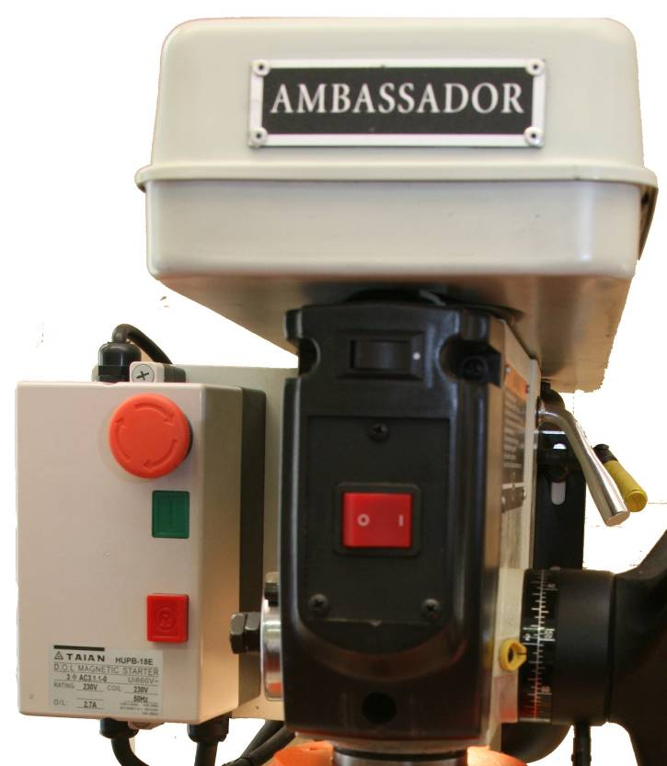
NVR Power Switch
Lamp Switch
Emergency Stop Button
Green Start Button
Red Stop Button

Control Panel at the front of the machine.

Testing the Ambassador Drill Stopping Systems

With the drill guard in place, press the green start button, the machine will start and the chuck will turn, press the Red Stop Button on the control panel, the drill will come to a complete stop.

Press the green start button, the machine will start, depress the Red Emergency Stop Button on the control panel, the drill will come to a complete stop. To reset the emergency stop button; turn to the right to unlock and the button will reset.

Press the green start button, the machine will start, depress the Mushroom Headed Footstop, the drill will come to a complete stop.

Reset the Mushroom Headed Footstop by pulling the mushroom head out until you hear it “click” back into position.

The Mushroom Headed Footstop is essentially part of the emergency stopping system and should not be routinely used to stop the drill.

The Emergency Stopping System will be tested regularly by the School Technicians as part of the routine maintenance of the machine tools.

The drill is now ready for use.

SECURING MATERIAL FOR DRILLING

It is essential to ensure that when drilling material, the workpiece is fixed securely to the table using clamps, vices or custom made jigs.

HSE: Drilling machines: guarding of spindles and attachments – Guidance Note PM3

17 “Many severe accidents have been caused by the workpiece revolving violently under the action of the drill through failure to securely clamp the workpiece to the table. It is necessary not only to have good clamping arrangements, but also to use them correctly”

Clamp: material can be fixed to the drilling table using G clamps.

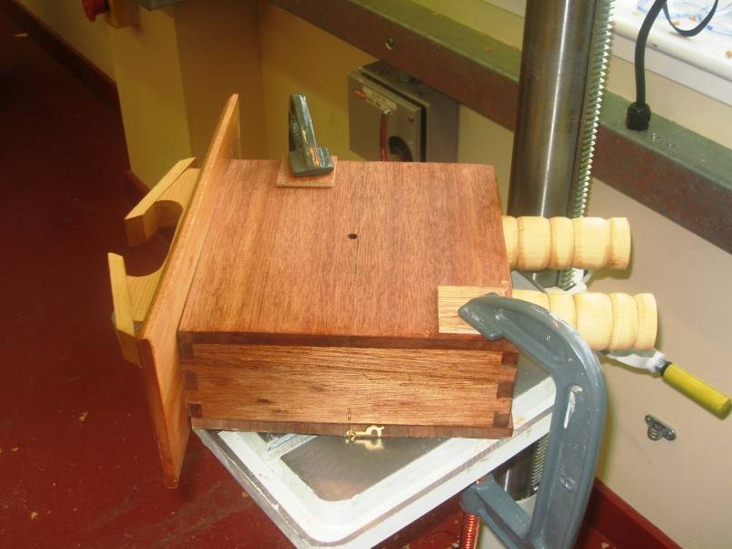

Vice: a metal nippy vice can be used to securely hold a small workpiece while drilling. The nippy vice should be secured to the table using the square bolts and clamps as shown below.

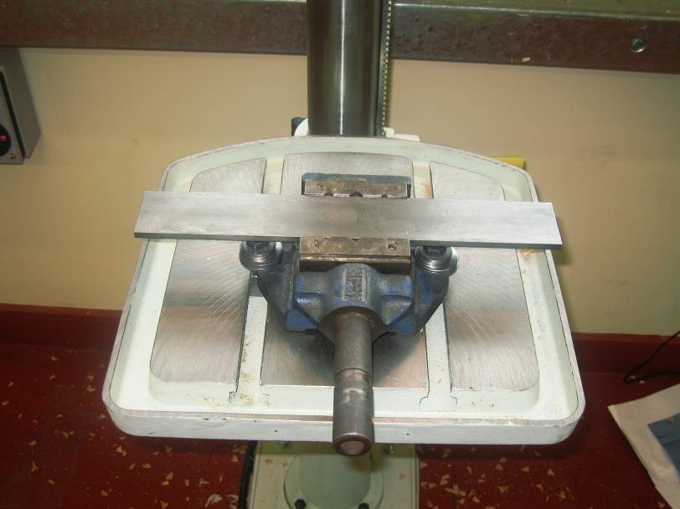

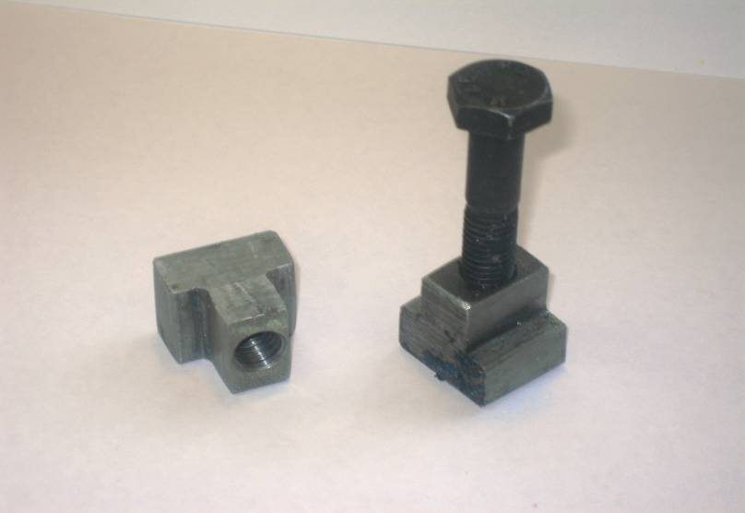

The T – bolts are designed to fit into the grooves of the drill table, the nippy vice is then held in place by securing the bolts.

Clamping Jigs: clamping jigs can be produced for specific drilling processes, these clamps are particularly useful for pupil exercises

The jig shown below is basically a wooden board that is clamped to the drill table using T-shaped clamping bolts. A small workpiece can then be clamped and secured to the jig using the adjustable side arms.

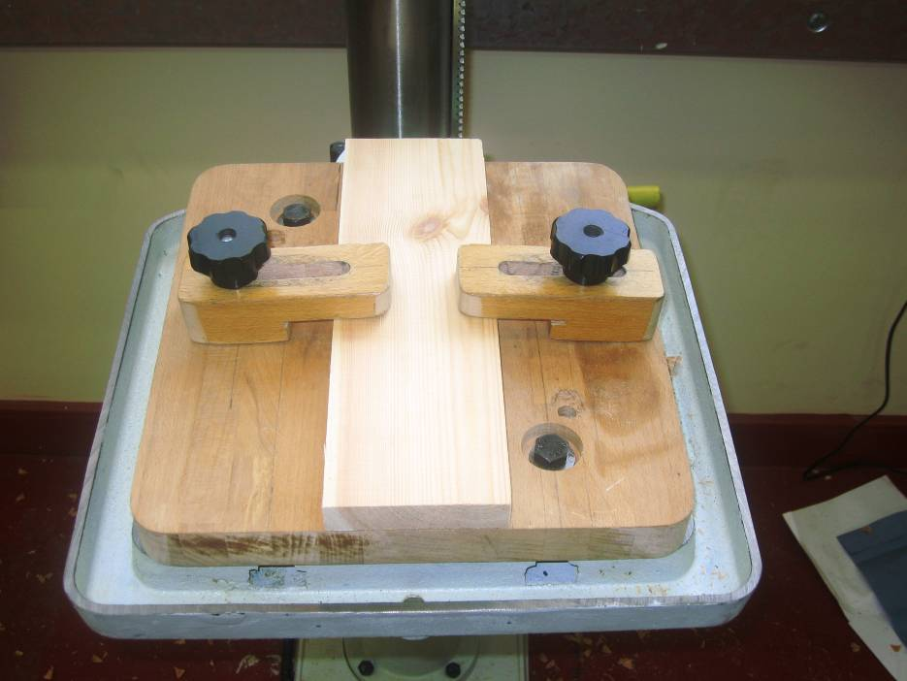

This jig can also be used along with the nippy vice as shown below

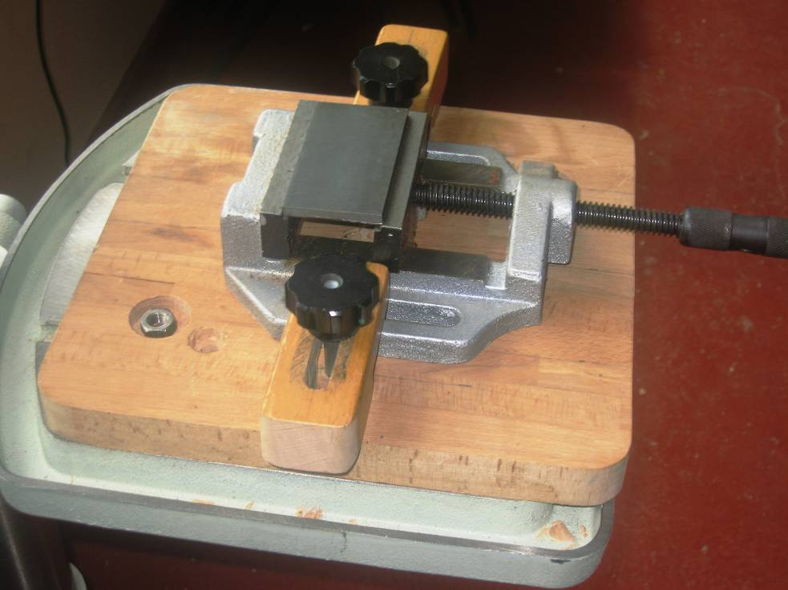

Preparing the Drill for Use

Selecting the correct cutter
It is essential that the cutter selected is suitable for the type material to be cut;

9.1.1 Twist Bit:

Usually referred to as “twist drills”, the front edges cut the material and the spirals along the length remove the debris from the hole. They can be used on timber, metal, plastics and similar materials. Most twist bits are made from:

- “High Speed Steel” (HSS), these are suitable for drilling most types of material, when drilling metal the HSS stands up to the high temperature.
- “Carbon Steel”, these bits are specially ground for drilling wood and should not be used for drilling metals, as they tend to be more brittle, less flexible than HSS bits.

Twist bits are also available coated with Titanium Nitride (TiN), these are easily identified by the gold like colour. This coating increases the hardness of the bit and adds self lubricating property. The coating is only really effective when drilling metal; it has little or no effect when working with other materials.

Twist drills are usually available in sizes 0.8-12mm plus. They are designed for drilling relatively small holes; they sometimes tend to clog when the wood is “green” so when drilling deep holes (especially in hardwood) the bits should be withdrawn regularly to remove the waste.

Special care is required when using the smallest sizes since these bits are thin and brittle.

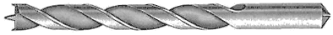
9.1.2 Spur Point Bit:
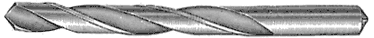
Also known as a wood or dowel bit, they have a central point and two raised spurs that help keep the bit drilling straight. The bit cuts timber very fast when used in a power drill and leaves a clean sided hole. They are ideal for drilling holes for dowels as the sides of the holes are clean and parallel. Sizes range from 3 to 10mm. Spur point bits should only be used for drilling wood or some plastics.

9.1.3 Bullet Pilot Point:
With their central point and two spurs, Bullet drills resemble spur point bits, but can be used in metal, wood and plastics. Unlike normal twist drills, the twisted flutes are ground away; making a truer, more accurate bit than normal twist bits. They cut a clean hole and cause little damage when they break through the back of the workpiece.
Bit sizes range from 1.5 to 13 mm.

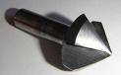
    - Countersink:

Although not a true 'drill', it is used in a power or hand drill to form the conical recess for the heads of countersunk screws. These bits tend to be designed for use on soft materials such as timber and plastics, not metals. When used with a power drill to counter sink an existing hole, the bit tends to 'chatter', leaving a rough surface. Better results be will obtained if the countersink bit is used before the hole is drilled, then take care to ensure that the hole is in the centre of the countersunk depression.
Countersinks are available with fitted handles so that they can be used by hand twisting, often easier than changing the bit in the drill when only a relatively few holes need countersinking.

9.1.5 Countersink with Clearance Drill:
These combination bits are quite clever; they drill the clearance hole and countersink it all in one stroke. Can be used in a power drill or some routers. Different bits are required for different size of clearance holes and they are probably not cost effective unless a large number of a given hole size need to be drilled and countersunk.

9.1.6 Flat wood Bit:

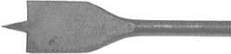
Intended for power drill use only, the centre point locates the bit and the flat steel on either side cuts away the timber. These bits are used to drill fairly large holes and they give a flat bottomed hole (with a central point) so are ideal where the head of a screw/bolt needs to be recessed into the timber - always use this bit before drilling the clearance hole for the bolt.
The larger bits require a fairly powerful drill to bore deep holes. The bits cause a lot of splintering as they break out the back of the workpiece - using a sacrificial backing board will reduce this. Flat wood bits are not really suitable for enlarging an existing hole.
Sizes range between 8 and 32mm.
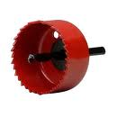

    - Hole Saw:

Used for cutting large, fixed, diameter holes in wood or plastic. They will usually cut up to a depth of 18mm - deeper versions are available. Best used in a power drill at low speed as the blade saws it's way through the material.

9.1.8 Combination Hole Saw:
Like the Hole Saw, these combination saws can cut large holes but they consist of a number of different sized round saw blades, usually ranging from about 25 to 62mm in diameter. Normally the blades are secured by a radial screw in the 'head', all blades other than the desired sized being removed before the screw is inserted to secure the required diameter blade. Best used in a power drill at low speed as the blade saws it's way through the material.

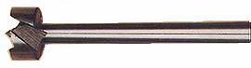
    - Forstner Bit:

Used to form holes with a flat bottom, such as for kitchen cupboard hinges. Best used in a power drill as there's little in the way of a central point. If used freehand, the positioning is difficult to control as there is no central pilot bit. .
Information courtesy of Drill bits – the different types: diydata.com
Please Note:
The above information on cutter / drill types is provided to assist the operator in selecting the correct type of cutter for a specific exercise. Operators should note that the drill guard must be in place for all cutting exercises and this will limit the size of certain cutters e.g. Forstner bit, Flatwood bit and Hole Saw etc. Maximum size 30mm

  - Local Restrictions

The use of sanding bobbins is strictly prohibited as recommended in the Glasgow City Council Health & Safety Department report on the Installation of new Pillar Drills:

“Sanding bobbins should NOT be used in pillar drills as they cannot be guarded to protect the operator. “

As well as the guarding issue, Control of Substances Hazardous to Health Regulations 2002 (COSHH) requires that the production of wood dust should be managed.
The pressure applied to the bobbin when in use, will eventually damage the spindle mechanism and this can lead to a costly repair which would not be covered by the warranty as this operation is strictly prohibited.

Selecting the correct drill speed
It is essential when selecting the drill speed that consideration is given to the material to be cut and the type of cutter / drill being used; refer to The WOOD Magazine’s Drill Press Speed Chart, Appendix A

9.4 Take - Off
The Ambassador Drill is designed to be used by only one person at a time; therefore there should only ever be one operator at the machine. The only other person who could be in the vicinity of the drill operator would be the class teacher in a supervisory capacity.

CUTTING MATERIAL

Using the depth stop

    - Position the workpiece and clamp securely to the drill table.

    - Set the drill table to a suitable working height; unlock the table by releasing the table lock at the rear. Using the crank handle raise or lower the table to reach the appropriate working height and lock in position.

    - Using the feed wheel, lower the drill / cutter to the top of the workpiece and hold in position.

    - Release the depth stop lock and adjust to the required cut depth (e.g. 10mm)

    - Lock the depth stop, the cutter can now only travel a distance of 10mm through the workpiece.

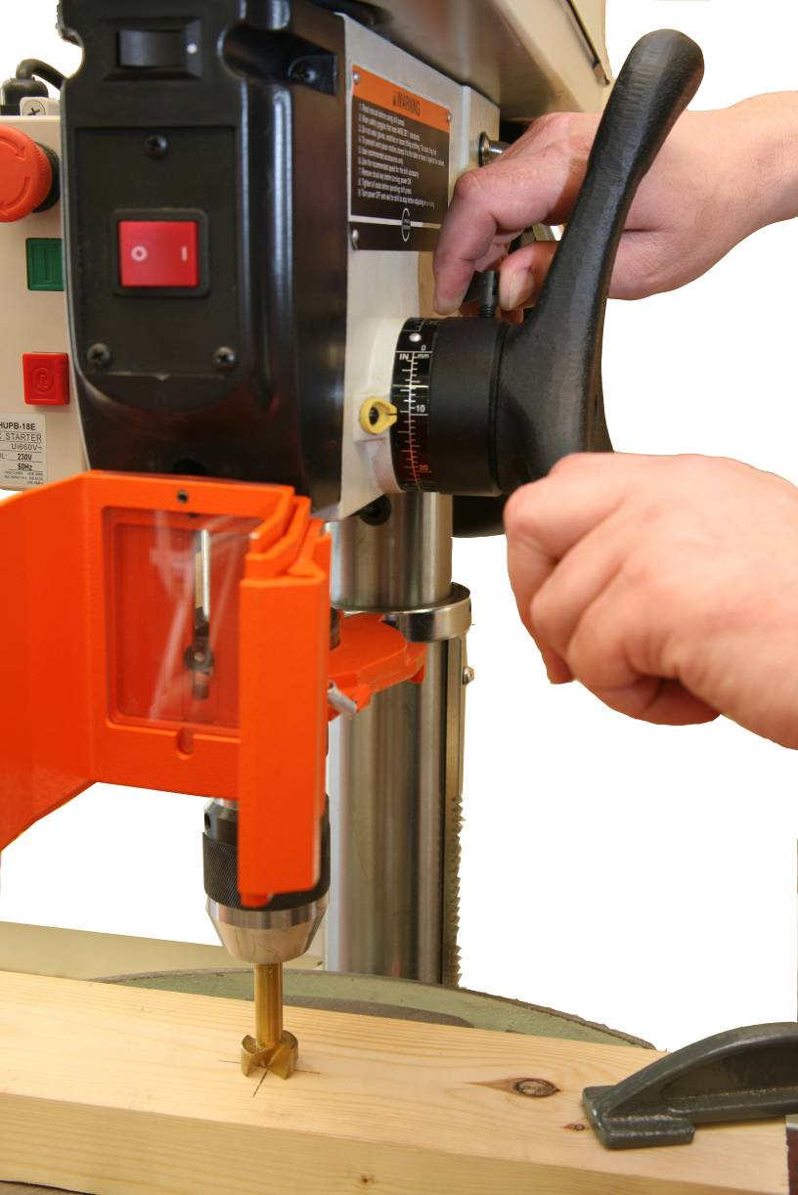
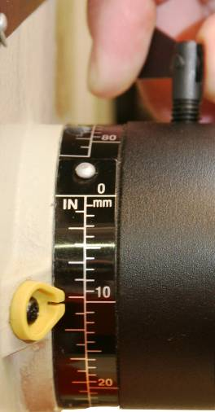

    - Lower the drill guard adjust and lock in position. Ensuring that the cutter and rotating parts are guarded from fully raised to fully lowered.

    - When drilling a through hole it is advisable to use a waste packer to protect the table, this is a waste piece of wood clamped beneath the workpiece.

  - Feed Speed

The force at which the drill is fed through the material is dependant upon the following factors:

Type of material being cut

Type of cutter / drill being used

Size of the hole to be cut

Sharp drills or cutters should work through the material without the need to impose excessive force. It may be necessary to step the drilling process; drill the workpiece in stages. This allows the shavings and swarf to be cleared, prevents heat build up and for acrylics provides a cleaner cut (less likely to crack or splinter).

Swarf / Wood Chippings
Swarf, also known as turnings, chips, or filings, are shavings and chippings of metal — the debris or waste resulting from metalworking operations. The chips can be extremely sharp, and this creates a safety problem, as they can cause severe injuries if not handled correctly. Swarf / wood chippings should never be removed when the drill is in operation.

.

POWER DOWN THE AMBASSADOR DRILL

Press the red stop button on the control panel to stop the Ambassador Drill, the chuck should come to a complete stop.

Switch off the Ambassador Drill NVR power button.

Switch of the Ambassador Drill isolator at the wall.

LEAVING THE AMBASSADOR DRILL SAFE FOR THE NEXT USER

Clear the drill table and the surrounding area of all debris and dust, using the Hepa filter Vacuum Cleaner as appropriate

Remove any drills or cutters

Leave the chuck guard in place

FAULT REPORTING

If any fault or damage is found when using the Ambassador Drill:

Switch off the Ambassador Drill

Isolate the Ambassador Drill and lock off the power using the padlock

Report any faults, defects or damage immediately to the appropriate Support Service Technician or the Senior Support Service Technician, who will arrange for any necessary maintenance or repairs to be carried out

If any fault or damage to the Ambassador Drill is reported, the following action should be taken by the appropriate Support Service Technician:

Ensure that the Ambassador Drill has been isolated from the power supply and that the power is locked off using the padlock

Attach a padlock to the Ambassador Drill isolator and retain the key

Label the Ambassador Drill “Do Not Use – Under Repair”

If appropriate carry out necessary repair or maintenance

If necessary contact TSS to arrange for repair

If any injury or near miss occurs to any person using the Ambassador Drill, or as a direct result of any person using the Ambassador Drill, then it must be reported using the Council Incidents Report Form; recording all the details of the incident.

REFERENCE MATERIAL
This document was compiled with reference made to the following material:

- BS 4163:2007 Health and Safety for Design and Technology in Schools and similar establishments – Code of Practice

- HSE: Drilling machines: guarding of spindles and attachments – Guidance Note PM3

- Ambassador Drill – Operation and Maintenance Instructions 2003

- The WOOD Magazine’s Drill Press Speed Chart (Appendix A)

- diydata.com

- The Design and Technology Association (DATA) – A Guide for Consultants, Trainers and Teachers for Health and Safety Training

- Technical Education – A Code of Practice

- Technician Support Service – Training Material

Please Note: The information on this chart is provided as guidance for the operator and not all of the cutters shown are suitable for Education use. The following restrictions apply:
- The drill guard as supplied must be used at all times and must fully enclose the cutter (see 4.4). This will restrict the size of cutters e.g. Hole Saws
- Sanding Bobbins must not be used (see 9.1.10)

Appendix A

