


Technician Guidance Sheets
Objectives - The objective of this Guidance Sheet is to instruct Support Service Technicians in the procedures in dealing with a Mercury spillage and the recording of equipment containing Mercury

Persons responsible - Senior Support Service Technicians and Support Service Technicians.

TGS / 20a

Managing Mercury

Issued by Technician Support Service

Date August 2010

SAFETY FLASH
M.S.F. 15(C) Date 5th December 2008
‘Equipment Containing Mercury’

Recommended Action
- Mercury containing equipment:- All Heads of Establishment should ensure that all members of staff are made aware of the need to identify any mercury containing equipment located within the school and an appropriate record should be established.
- Mercury containing equipment:- should be stored in a safe area where it is not likely to be knocked over or damaged.
- Disposal:- Any items of mercury containing equipment that are not of recognised requirement of the curriculum should be removed from use and disposed of appropriately. Contact should be made with Technician Support Services for uplift

Further Guidance / Advice

Education Services Master Safety File No. 15 – Collection, Removal & Disposal of unwanted or hazardous substances.
Education Services Master Safety File No. 11 – Accident & Incident Reporting Procedures

In addition to the above Glasgow City Council Safety Flash MSF 15(c)
TSS would like to further advise all establishments/technicians that the following procedures should be put into action when dealing with a mercury spillage.

Mercury and its uses

Mercury is used mainly in thermometers, barometers and sphygmomanometers. Within the curriculum it can also be used as a solvent for other metals and in the making of amalgams. It is toxic by inhalation and can also be easily absorbed through the skin and into the body with a danger of cumulative and systematic effects including: headaches, tinnitus, dermatitis, anorexia, fever, toxic pneumonitis and gastrointestinal haemorrhage. For further information see SSERC Safetynet Hazardous Chemicals. (www.sserc.org.uk)

Mercury quickly evaporates at room temperature. As mercury divides into tiny globules, spillages can present a vast surface area from which evaporation takes place. Mercury spillages in an unventilated room can rapidly give rise to concentrations of mercury in the air of many times the accepted levels. Therefore, due to the high toxicity of its vapour it is important to clean up mercury as thoroughly as possible.

Alternatives to mercury containing items as advised by SSERC:

Where possible substitute mercury filled thermometers with alcohol or ‘rotatherm’ types. The use of mercury thermometers is justified for older pupils who may require higher accuracy or speed of response. These thermometers should be handled carefully to avoid breakage. The device of the anti-roll flag of PVC or sellotape attached to the top end is useful.

With regards to ovens, the alcohol based thermometers will only be suitable in ovens when they are being used as incubators or on low range. Simmerstat controls (on the front of the oven) can be calibrated and the knob setting then used to indicate the approximate temperature.
For higher temperatures use a thermocouple probe. See Appendix 1

General Points
- Keep a pre-prepared mercury spillage kit available for immediate in the event of a spillage. See Appendix 2
- Every spillage should be dealt with, no matter how small.
- Vacuum cleaners should never be used to remove mercury spillages.^{[1] [4]}
- Mercury must never be disposed of via sinks or ordinary waste bins. ^{[1]}
- Where a trap below a sink has been contaminated, it should not be flushed with water but should be logged as a repair with the facilities management to have the trap disconnected and it can then be decanted and collected in a sealable container and disposed of as hazardous waste. ^{[1]}
- Clothing that has come into contact with the mercury directly must not be washed in the washing machine, but must be discarded, double bagged, in the normal house hold refuse. ^{[1]}
- If the spill is on upholstery or carpet and the mercury can not be retrieved, the area of contaminated upholstery or carpet may need to be removed and disposed of as hazardous waste.^{[1]}
- Ensure all cuts and grazes on hands are covered by plasters.
- Wear rubber or nitrile gloves.^{[4]}
- Place all items used to remove the spillage i.e. gloves, paper towels, syringes etc into a plastic bag and store for disposal by council approved waste disposal company.
- Mercury attacks gold and silver jewellery, therefore remove such items prior to dealing with the spill.
- Thoroughly wash hands in a stream of cold water with liquid soap and dry hands with disposable paper towels.
- Do not take any action which will further disperse the mercury e.g. brushing.
- Do not walk over or stand on the mercury spillage during the treatment process. ^{[1]}

Primary Schools

All Primary schools should be advised to remove all mercury sources from schools as special chemical waste disposal. Contact TSS for further advice.

Technician Support Service
Tel. 0141 276 8550
admin@TSS.ea.glasgow.sch.uk

Secondary Schools
Dealing with a Small Scale Spill (e.g. broken thermometer)
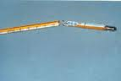
Anything up to approximately 5 cm³ (10 standard thermometers) is considered as a small scale spill. Anything over 5 cm³ a stock bottle or open source with a mercury reservoir should be regarded as a large scale spill.

Evacuate and ventilate the area by opening windows for a minimum of 30 minutes. Do not use internal doors as a means of venting the room as this will allow vapours to travel along the corridor. Delay further working in this area until the minimum ventilation time has elapsed. If the area of the spill has poor ventilation the time allowed must be increased accordingly. ^{[1] [2]}
- Remove rings, bracelets, watches etc.
- Wear rubber or nitrile gloves.
- Carefully pick up any broken glass and place in a plastic jar with a lid to prevent any vapour escaping (you may need a container tall enough to hold broken thermometers). Label the jar Mercury – Contaminated Waste. Toxic/Irritant.
- Use strips of wood, e.g. wooden spatulas or thin card to gather the bulk of mercury together. ^{[1] [4]}
- Use an appropriately sized plastic syringe to draw up the mercury and place in another plastic jar with lid. ^{[2] [3] [4]}
- Secure the lid with adhesive tape and label the jar, Recovered Spilt Mercury. Toxic
- The above containers can be reused for further small spillages.
- All containers should be stored with the toxic chemicals until sufficient has been collected for disposal by council approved waste disposal company, contact TSS to arrange. ^{[1] [3] [4]}

Technician Support Service
147 Berkeley Street
Glasgow
G3 7HP
Tel. 0141 276 8550
admin@TSS.ea.glasgow.sch.uk

Residual Clean Up

A dust mask (FFP2) should be worn along with lab coat, goggles and disposable gloves during the clean up. ^{[3]}

To remove any remaining mercury from smooth surfaces, mix precipitated copper powder with sufficient 2M hydrochloric acid in a plastic beaker to make a thick paste and spread the paste over the contaminated area with a plastic spatula, the paste will pick up the fine mercury droplets.^{[4]} Place a dust pan inside a plastic bag and sweep up the paste with a paint brush (approx 3cm) on to the dust pan.^{[3]} When the waste has been gathered the plastic bag can be inverted with the waste safely contained, the used brush should be placed in the plastic bag and labelled. Mercury – Contaminated Waste. Toxic/Irritant. ^{[1][4]}
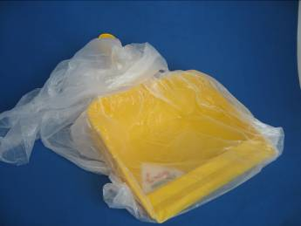

or

To remove remaining drops of mercury from rough surfaces and cracks, heat some calcium hydroxide/flowers of sulphur (1:1w/w) with a little water to make a slurry, spread over the contaminated area and leave to dry. ^{[3] [4]} When dry place a dust pan inside a plastic bag and sweep up the paste with a paint brush (approx 3cm) on to the dust pan. When the waste has been gathered the plastic bag can be inverted with the waste safely contained, the used brush should be placed in the plastic bag and the bag labelled. Mercury-Contaminated Waste. Toxic/Irritant

Wipe the area with damp paper towels and place in the plastic bag labelled Mercury – Contaminated Waste. Toxic/Irritant ^{[1][4]} which should be stored as toxic material until disposal by council approved waste disposal company.

Dealing with a Large Scale Spill in all Educational Establishments
(Spills greater than approximately 5 cm³)

Any stock bottle of mercury or open source with a mercury reservoir maybe regarded as a large scale spill i.e. sphygmomanometer (blood pressure monitor) which typically holds 30-40ml.
- Evacuate the area and ventilate by opening windows, not the internal doors as this allows vapours to travel along the corridor. Control access possibly by locking the door
- Inform the School Management Team (SMT) who in turn should contact the following agencies:
Within working hours: Health & Safety (Education Services) 0141 287 3734
Out of hours: Local Fire Brigade
- An accidents and incident report form should be completed and forwarded to the following:-

Yellow copy of Incident Report form to
House 6
94 elmbank Street
Glasgow
G2 4DL

Pink copy of the Incident Report form to
Education Services
Health and Safety
Wheatley house
25 Cochrane Street
Glasgow
G1 1HL

Recommended Action

It is recommended that a list be made of all items in the school that contains mercury and a record kept for future reference. In secondary schools the stock of mercury containing vessels and devices must be recorded on an annual basis. See Appendix 3
Appendix 1
Mercury Alternatives

Suggested alternatives to devices which contain mercury

Appendix 2
Mercury Spillage Kit

- polythene bottle for recovered mercury
- polythene bottle for mercury contaminated waste
- 250g precipitated copper powder
- 100ml 2M hydrochloric acid
- 250ml polypropylene beaker
- a mixture of 500g flowers of sulphur and 500g calcium hydroxide
- paintbrush, 3cm wide
- 10 wooden spatulas
- disposable gloves, face mask(FFP2)
- plastic bag
- dustpan

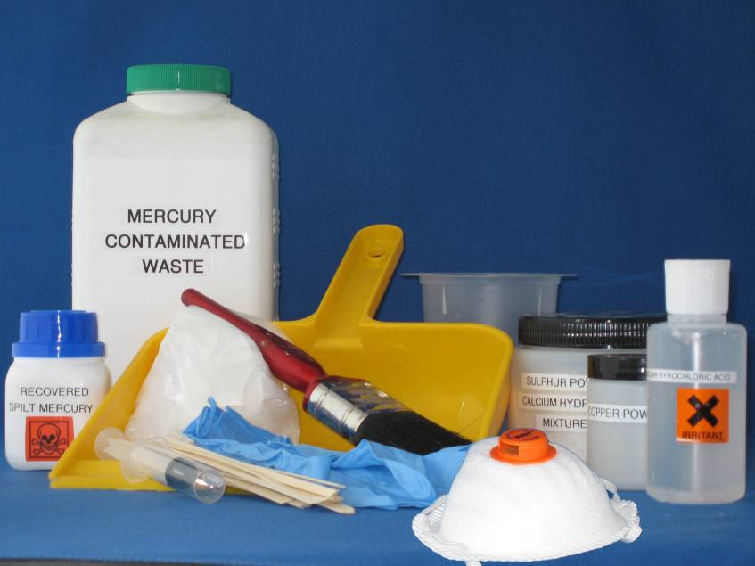

References

- Health Protection Agency – Mercury in residential settings: step-by-step guide to cleaning up spills
- Technician Support Service - www.TSSglasgow.org
- SSERC – www.sserc.org.uk
- CLEAPSS – Laboratory Handbook (para 7.7,12.13)
- Wikipedia
Mercury Record Appendix 3
Establishment:

Item | Number Held | Location | Date | Removed | Signature | Date

