

Glasgow City Council

EDUCATION SERVICES

Technician Support Service

Technician Guidance Sheets
TGS / 18

Safe Use: Flamefast DS430S Chip Forge / Brazing Hearth

Issued by Technician Support Service

Date June 2009

Objectives - The objectives of this bulletin are to ensure the safe use of the DS430S Chip Forge / Brazing Hearth and to highlight the functional changes in the new machines when compared to previous models used in secondary schools.

Persons responsible – School Technicians (core skills Technical) and Technical Teaching Staff

Safe Use: Flamefast DS430S Chip Forge / Brazing Hearth

AIMS AND OBJECTIVES

Aims
To instruct teaching and technician staff in the safe use of the Flamefast DS430S Chip Forge / Brazing Hearth and to highlight and demonstrate the functional changes in the new forge when compared with previous models used in secondary schools.

General Objectives

To demonstrate the safety precautions necessary for the safe operation of the chip forge / brazing hearth.

To demonstrate the functions of the safety devices.

To demonstrate how to prepare the Chip Forge / Brazing Hearth for safe use.

To demonstrate how to operate the Chip Forge / Brazing Hearth to carry out its functions safely.
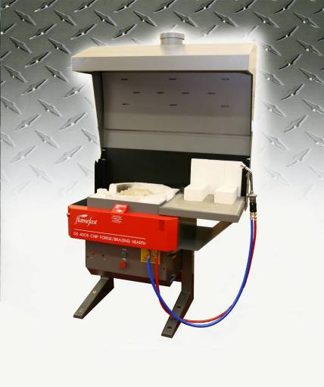

Specific Objectives

Know and understand the hazards associated with use of the chip forge / brazing hearth.

Know, observe and heed the advice of, the safety signs which apply to the chip forge / brazing hearth.

Know what personal protective equipment (PPE) is mandatory when using the chip forge / brazing hearth.

Know which personal protective equipment is required to be worn when observing the use of the chip forge / brazing hearth.

Know that the chip forge / brazing hearth requires fume extraction operating when the machine is in use.

Know that if the fume extraction system is faulty or under repair, the chip forge / brazing hearth must not be used.

Become familiar with the parts of the chip forge / brazing hearth and their functions.

Be aware of how to safely hold or position materials when using the chip forge / brazing hearth.

Know that the power to the chip forge / brazing hearth must be switched off and allowed to cool down before making any adjustments, cleaning or maintenance.

Be aware of the materials that can and cannot be safely used.

Be aware of the location and function of the emergency stop fitted to this appliance.

Be aware of the location and function of the gas isolation valves.

Become familiar with the “power up” and ignition procedures for the chip forge / brazing hearth.

Know and adopt the correct position/stance when using the chip forge / brazing hearth.

Know that the chip forge / brazing hearth is designed to be used by only one person at a time.

Become familiar with the “power down” procedures and isolation of the chip forge / brazing hearth.

Know to leave the machine clean, tidy and in a safe condition for the next operator when work is completed.

Know to always indicate when the chip forge / brazing hearth was last used so that passers by are aware of the residual heat retained within the chips after use.

Know to never leave a chip forge / brazing hearth unattended when the machine is running.

Know to never leave a chip forge / brazing hearth, after use, so that it can be readily “powered up” and used by unauthorised persons.

Know that the chip forge / brazing hearth should never be used as a supplimentary heating source.

Know to report any damage or faults immediately and know who to report them to.

Flamefast DS430S Chip Forge / Brazing Hearth

Extraction Hood
Ignition Electrode

Heat Reflective Bricks

(RF80) Brazing Torch

Brazing Hearth

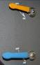

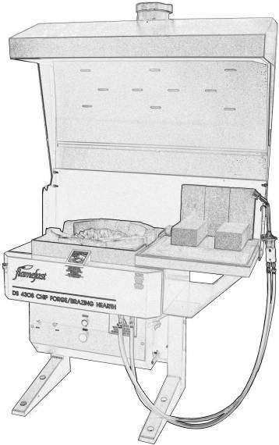

Heat Retentive Chips
Burner Tile
Ignition Button
Amber
“Gas Proving”
Indicator Light

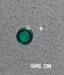

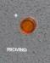

Gas / Air Control Valves

Green Neon
(Lockable)
Red Stop Button
Green Start Button

USAGE

The Flamefast Chip Forge / Brazing Hearth combines a modern efficient chip forge and a brazing hearth fitted to the side with a single valve controlled RF80 torch.

HAZARDS

Fumes produced during either forging or brazing operations.

Burns from material being heated, chips, tools in use etc. (especially black hot metal). Ceramic chips remain hot for some considerable time after the heat source has been removed.

Infra-red radiation from hot surfaces.

Foreign materials present in a forge can explode or be ejected e.g clinker.

Quenching of hot metals, particularly tubular components, present a risk of scalding.

Environmental: keep area around machinery clear of surplus materials, wood waste and other tripping or slipping hazards.

Inadvertent starting/stopping of the machine.

Unauthorised persons using the machine.

CONTROL MEASURES

Safety Signs
Blue – Mandatory Instructions Yellow - Warning

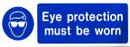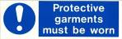

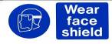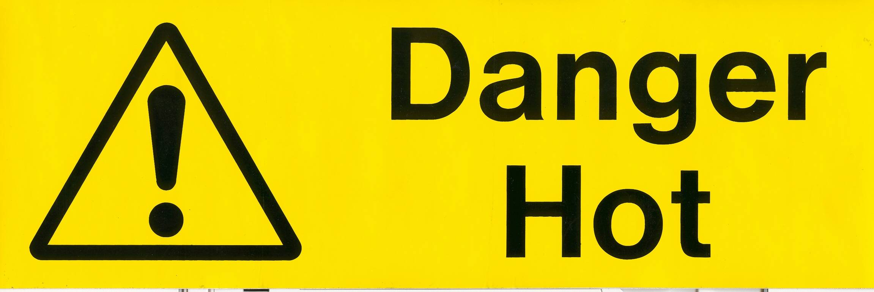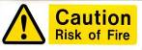

Personal Protective Equipment (PPE)

Goggles (BSEN-166-349B) – (Those observing must be wearing suitable goggles)

Operator must wear a suitable face shield

Operator must wear protective gloves

Suitable leather apron

Suitable protective footwear

Loose clothing must be secured and long hair tied back

Emergency Stop Systems

Room Emergency Stop System – various sites around the room

Gas isolator – sited on the wall close to the forge.

Fume Extraction

The Flamefast Chip Forge / Brazing Hearth as installed comes fitted with a fully COSHH compliant fume extraction system. The fume extraction system must be switched on each and every time the forge and / or brazing hearth is used and must remain in operation for at least 30 minutes after the forge has been switched off. All the forges in Glasgow schools have been fitted with a Differential Pressure Switch (DPS) to ensure that the forge cannot be operated without the extraction sytem as regulation IGE/UP/11 section 8.1.2.4.

Differential Pressure Switch
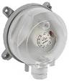

The DPS is generally sited on the wall behind the fume extraction hood and functions as follows, when the forge is switched on the air pressure in the fume extraction hood is measured, if there is insufficient air flow (i.e. the fume extraction is not in operation) the soleniod controlling the gas flow is closed and the gas will not flow into the forge or the torches system.
The forge cannot be used without the extraction.

Forge Usage Board

After use the ceramic chips in the forge remain hot for some considerable time after the heat source has been removed. Therefore it is necessary to provide a suitable warning system that will inform “room users” that the forge has been recently used and there is danger. Support Service Technicians (core skills technical) will have prepared a warning board to be completed and displayed on or at the forge to warn of this danger.

e.g.
Forge Used: Monday 12th January 2009

Time: 10:30am

SAFETY CHECKS BEFORE USE

Clear Working Area around the Chip Forge / Brazing Hearth
The area around the Chip Forge / Brazing Hearth should be regularly checked to ensure that it is clear of any slipping or tripping hazard, since anyone carrying a hot object will not be concentrating on the floor.

Chip Forge: Pre checks
Always check the condition of the ceramic chips, remove any clinkers, slag and foreign objects and “riddle” the chips to remove any debris if required. Check the condition of the burner tile, the holes should be clear and the tile undamaged. There should be a sufficient amount of ceramic chips to cover the burner tile (approximately 12.5 Kg). The chips, as supplied, are made from a ceramic “heat retentive” material and are designed to absorb and retain the heat in order to exchange the heat to the material placed in the forge. Only the ceramic chips provided with the forge or Flamefast approved chips should be used with the forge.

Brazing Hearth: Pre checks
The brazing hearth is lined with heat resistant refactory and provided with specially tested “heat reflective” blocks and is designed to reflect and concentrate the heat on the material being worked on. Only the heat reflective blocks provided with the brazing hearth or Flamefast approved blocks should be used. Before use check the condition of the brazing surface and the blocks and remove any debris or foreign objects.

RF80 Torches
The RF80 Torches as supplied with the Flamefast Chip Forge / Brazing Hearth are regulated by a single control valve and are used in brazing and for lighting the forge. When not in use they should be hung by the hook at the side of the brazing hearth. Avoid hanging the torch by the control valve as this may cause damage.

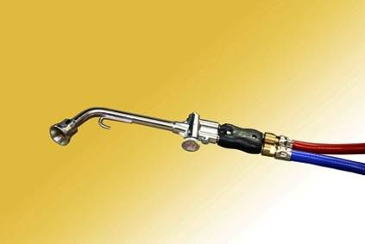
Control
Valve

Always check the condition of the torches before use, visually inspect the hoses for any obvious signs of damage, check that the hoses are securely connected to the forge. Ensure that the control valve is in the “off” position, that is turned fully clockwise.

Any damage found should be reported to the appropriate Support Service Technician (core skills technical) or the Senior Support Service Technician.

POWERING THE CHIP FORGE / BRAZING HEARTH

Energise the Chip Forge / Brazing Hearth

Switch on the power supply to the work room, this may be controlled by a keyswitch

Switch on the mains gas supply to the work room (This maybe supplied from an external “proving” system)

Switch on the forge extraction system – the Flamefast Chip Forge / Brazing Hearth will not operate without the extraction system switched on

Ensure that the forge “gas” and “air” valves are switched “OFF” (the handles should be in a horizontal positon). The gas supply for the brazing torch does not come through these valves so ensure that the brazing torch is switched “OFF” (turn the control valve fully clockwise)

Switch the machine isolator to the “on” position

Switch on the gas supply to the forge: the gas valve should be situated on the wall towards the rear of the forge

Insert the key into the keyswitch and release the RED stop button (remove the key for safe keeping)

Press the green start button, this will initiate the “Proving Cycle”, the amber gas proving neon will illuminate

The “Proving Cycle” or “Gas Soundness Test” is to check that there are no leaks in the system or that the torches or valves have been left open after previous use. A small flow of gas is released into the system and the pressure in the system is measured, if the pressure is maintained then the system is sound and has no leaks or open valves. The “Proving Cycle” can take up to 30 seconds, but if there is a small amount of gas still in the system after the previous use, the forge can “Prove” very quickly and go straight to “Gas On”.

When proving is complete the green neon will illuminate indicating that the “Gas Proving” is complete and the gas is now “ON”

Igniting the RF80 Torch / Forge

To light the brazing torch, hold the nozzle at the cage containing the ingnition electrode

Press the ingnition button at the front of the forge, sparks should appear at the electrode

Turn on the torch, ¼ turn anti-clockwise, at the control valve

Hold the nozzle of the torch near the ignitor while pressing the ignition button, when the torch lights release the ignition button

If the torch is to be used for brazing adjust the flame, using the control valve, as required

Igniting the Forge

To light the forge, hold the lighted torch close to the forge burner tile

Turn the “air” and the “gas” valve fully on until a smooth ignition is achieved

Turn “OFF” the brazing torch

The forge is now ready for operation

The flame in the forge is “increased or decreased” by adjusting the “air” valve

Please note: Never allow the forge to burn on full when not in use: Turn the flame down
Damage will soon occur to the unit if left to burn on the highest setting.

Turning off the Chip Forge / Brazing Hearth

DO NOT SWITCH OFF THE EXTRACTION

If the brazing hearth was in use, switch off the torch by turning the control valve fully clockwise

Hang the torch by the hook at the side of the hearth (avoid hanging the torch by the control valve as this may cause damage)

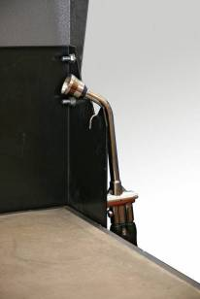
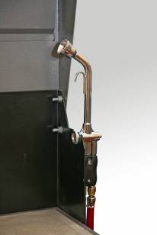


X

If the forge was in use, close the “gas” valve then close the “air” valve

Press the RED stop button (this will lock the unit off and will require the key for restart)

Display the “FORGE USAGE BOARD” prominently at the forge, indicating the date and time that the forge was last used

Allow the extraction system to run for a further 30 minutes after shut down before turning it off

Common Faults during start up (excluding faulty gas / electrical supply)

Fault | Reasons
Forge will not prove | - Extraction not switched on  - Gas not switched on  - Key stop not released  - Hearth Gas valve left on  - Brazing Torch valve left on
No “Gas On” Light | - Forge has not proven (see above)
Spark Ignitor (not sparking) | - Forge has not proven (see above)  - Electrode damaged (contact TSS)
Brazing Torch will not ignite | - Control valve not switched on (turn anti-clockwise to open)
Started forge without key | - Improper shut down – key stop not depressed after previous use – forge left UNSAFE

FAULT REPORTING

If any fault or damage to the Chip Forge / Brazing Hearth is reported, the following action should be taken by the appropriate Support Service Technician

Ensure that the Chip Forge / Brazing Hearth has been isolated from the power supply and that the power is locked off using the red padlock

Attach a padlock to the Chip Forge / Brazing Hearth isolator and retain the key

Label the Chip Forge / Brazing Hearth “Do Not Use – Under Repair”

Advise the necessary staff that the Chip Forge / Brazing Hearth cannot be used

If appropriate carry out necessary repair or maintenance

If necessary contact TSS to arrange for repair

REFERENCE MATERIAL
This document was compiled with reference made to the following material:

- BS 4163:2007 Health and Safety for Design and Technology in Schools and similar establishments – Code of Practice
- Flamefast Chip Forge / Brazing Hearth–Instructions Manual
- The Design and Technology Association (DATA) – A Guide for Consultants, Trainers and Teachers for Health and Safety Training
- Technical Education – A Code of Practice 1995
- Technician Support Service – Training Material

