


Technician Guidance Sheets
TGS / 15

Fitting a CD/DVD drive belt in a managed service pupil PC

Issued by Technician Support Service

Date December 2008

Objectives - The objective of this Guidance Sheet is to instruct Support Service Technicians in the method of replacing or refitting a drive belt to a CD/DVD drive of a managed service pupil PC, to re-enable the disc drawer mechanism.

Persons responsible – Senior Support Service Technicians and Support Service Technicians.

TECHNICIAN SUPPORT SERVICE
Technician Guidance Sheet

Fitting a CD/DVD drawer drive belt

The following remedial action should be undertaken by Support Service Technicians to replace or refit the CD/DVD drawer drive belt in a managed service pupil PC, using the tools listed below.

Tools

- Drive Belt (19mm diameter, square cross section 1.2mm)
- Pair of forceps or tweezers
- Paper clip (straightened)
- Small torch (optional)

Procedure

- Open CD/DVD drawer, if it is not already open, by inserting a straightened paper clip (or similar) into the small hole located beneath the drawer and firmly pushing it forward as illustrated (Diagrams 1).

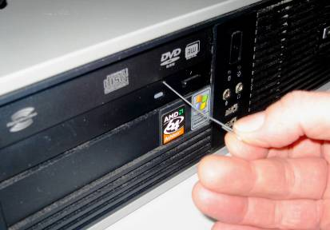
Diagram 1

- Ascertain if the old belt is still in the drawer compartment.
  - If it is, and is still fitted in position on the roller wheels, there may be another reason why the mechanism is not working (call the Mitel helpdesk).
  - If the belt is lying loose within the drive, and is still in a usable condition, it can be refitted in the mechanism.

- Towards the front of the housing are two roller wheels (the larger approx 25 mm diameter, the smaller approx 8mm diameter). Take the drive belt and position it around the larger roller wheel; it may be helpful using a finger to hold it in position. Using the forceps, grasp the end of the drive belt nearest to the smaller wheel and stretch it over this wheel into position (Diagrams 2 and 3). A small torch or other light source may be helpful at this stage to illuminate the work area.

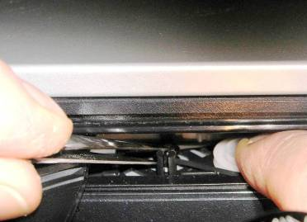
Diagram 2

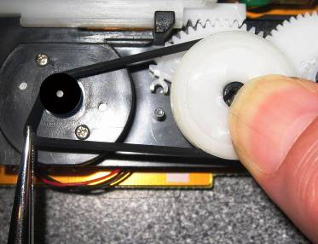
Diagram 3

- When the drive belt is seated in position, remove your finger from the larger wheel and withdraw the forceps from the housing. The drawer is now able to close and the CD/DVD drive is ready for use.

There are other less common models of CD drives used in some Managed Service PC’s, using different sized belts. This Guidance Sheet refers to the most common type, which requires the 19mm drive belt.

If required, additional drive belts for this procedure can be obtained free of charge by contacting TSS admin (Telephone: 0141 276 8550 or E-mail: admin@TSS.ea.glasgow.sch.uk).

