


Technician Guidance Sheets
TGS / 14

Securing PC cases to prevent intrusion

Issued by Technician Support Service

Date June 2008

Objectives - The objective of this Guidance Sheet is to instruct Support Service Technicians in the method of securing the outer casing of school PC’s to prevent accidental access, or inhibit intentional access by individuals.

Persons responsible – Senior Support Service Technicians and Support Service Technicians.

TECHNICIAN SUPPORT SERVICE
Technician Guidance Sheet

Method for securing PC access panels

The following is a guide to the remedial action that can be carried out by technicians to secure the case and attached peripherals of the HP Compaq DC5750 (or similar) as used in schools.
Please be aware that 3ED will not be held responsible for damage caused to peripheral cables resulting from the following procedure.

Advantages

There are three main advantages in carrying out this exercise:

- To prevent accidental, or inhibit intentional access to the Desktop PC.
- To reduce the chances of causing damage to the internal electronics of the PC.
- To prevent the risk of theft of component parts and peripherals.

Tools required

- Pair of Side Cutters - supplied via TSS
- Cable Ties (approx 188mm x 8mm) – supplied via TSS
- Screwdriver or similar tool

Method

- Ensure that the access panel is properly housed to the main chassis of the PC and that the hasp (metal loop) is fully engaged in the locating slot at the back of the case (Figure 1).

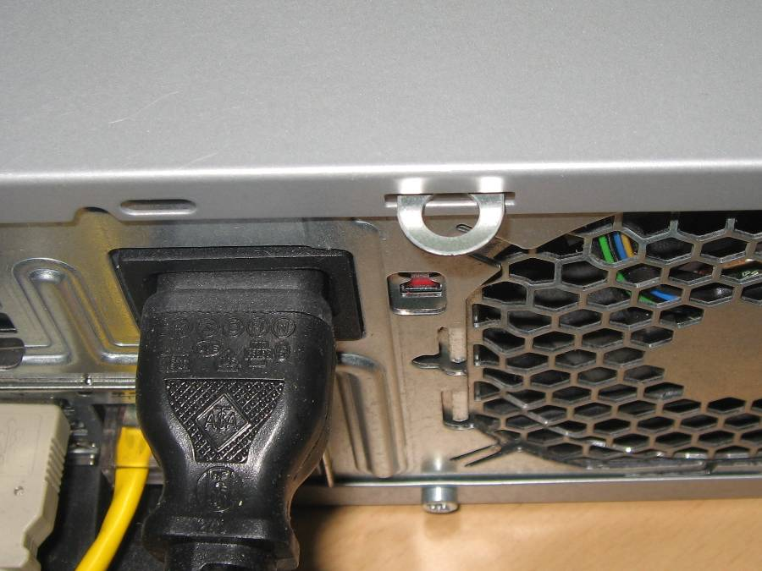
Figure 1

- Slide the end of the cable tie through the hasp and then thread it through the ratcheted locating slot for no more than 2 inches (Figure 2).
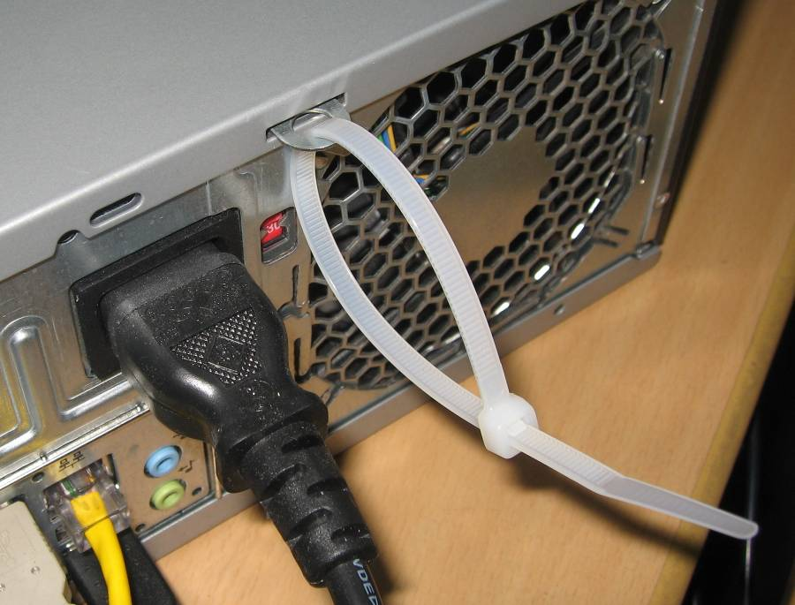
Figure 2

- Feed the mouse and keyboard cables through the resulting loop of the cable tie (Figure 3).

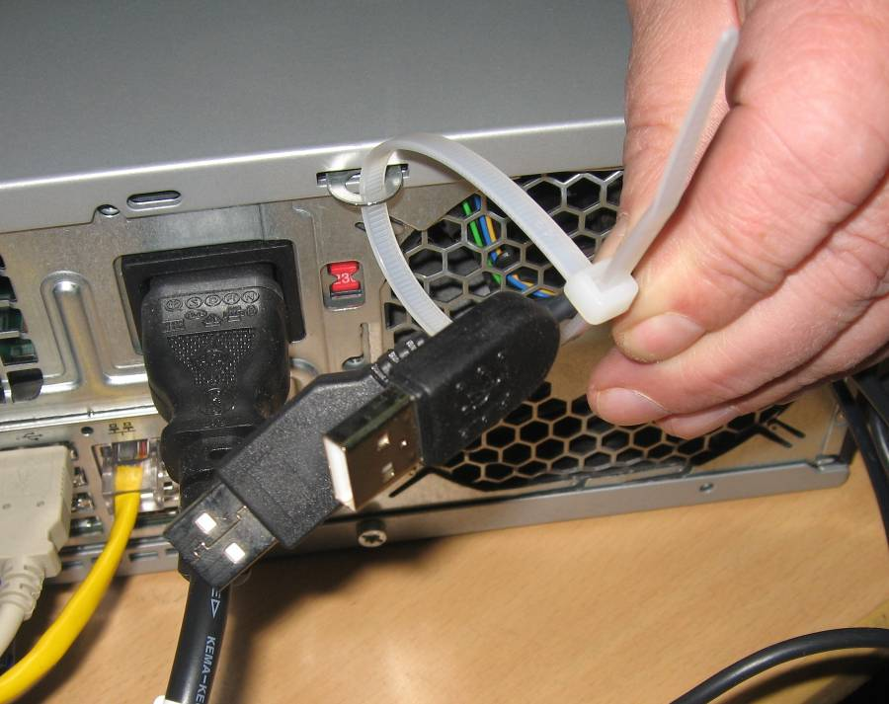
Figure 3

- Insert the screwdriver into this loop and carefully pull the cable tie until it is touch tight to all the cabling (Figure 4).
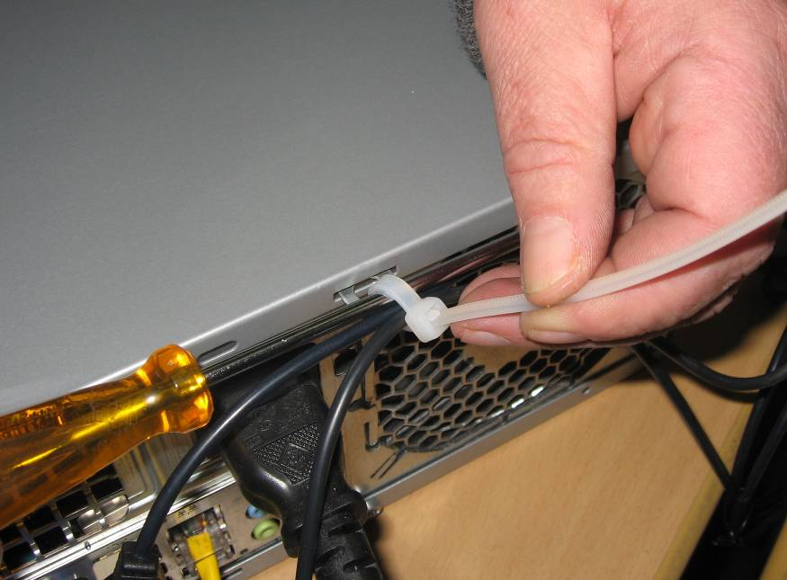
Figure 4

Figure 4

- Carefully slide the screwdriver out of the loop, allowing sufficient slack to prevent cable damage while still securing the asset, cut and trim the protruding end of the cable tie back until flush with it’s housing (Figure 5).

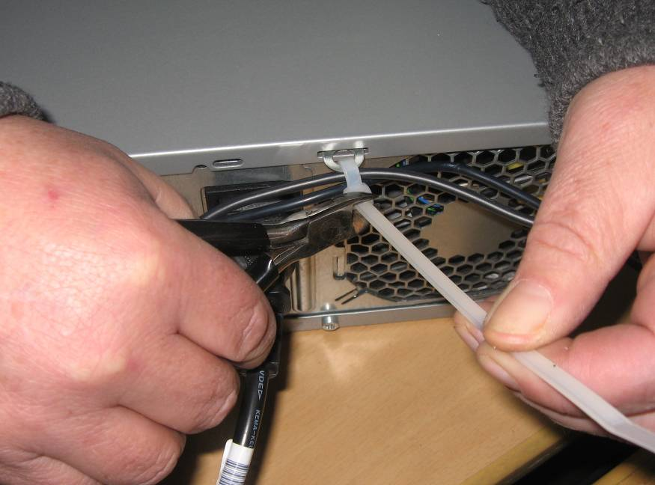
Figure 5

Follow Up

The above procedure should be repeated following any invasive repair or upgrade work conducted by a Mitel engineer.
The condition of the cable ties should be checked on an annual basis and recorded on the attached “PC Case Security Records” sheet. Any remedial work should be carried out where necessary.

Glasgow City Council

Education and Social Work Services

Technician Support Service

PC Case Security Records

Department | Room No. | Total Number Of PC’s In Room | Number Of PC’s With Tie Wraps | Number Of Tie Wraps Added | Inspection Date | Comments

Technician Name (print) Signed Date

These records must be kept by the Senior Support Service Technician for 5 years and be made available for inspection and audit as required.

