

Glasgow City Council

EDUCATION SERVICES

Technician Support Service

Technician Guidance Sheets

TGS / 13

Technician Guidance Sheet TGS/13

HZDQ 450-2 Numatic HEPA Filter Vacuum Cleaner

Inspection and Cleaning

Issued by Technician Support Service

Date Updated June 2009

Objectives - The objectives of this guidance sheet are to ensure the HZDQ 450-2 Numatic HEPA Filter Vacuum Cleaner is regularly emptied and cleaned to maintain maximum extraction efficiency.

Persons responsible - Senior Support Service Technicians and Support Service Technicians (core skills technical)

TECHNICIAN SUPPORT SERVICE

HZDQ 450-2 Numatic HEPA Filter Vacuum Cleaner

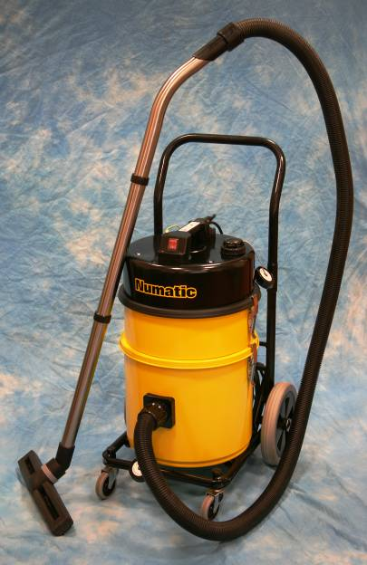

Numatic High Efficiency HEPA Filter Vacuum Cleaner (HZDQ 450-2)

The Control of Substances Hazardous to Health (COSHH) Regulations 2002 places a duty on all employers to ensure that exposure of their employees to substances hazardous to health is either prevented or, where this is not reasonably practicable, adequately controlled. To this end every school was issued with at least one Numatic High Efficiency HEPA Filter Vacuum Cleaner (HZDQ 450-2) for use within the technical department; for machine tool maintenance and dust removal from practical areas.

The Vacuum Cleaner operates with a “triple filter system” to achieve maximum dust containment. In order to balance efficient containment and collection it is essential to ensure that the filters within the unit are maintained and replaced regularly.
Vacuum Filters
HZDQ 450-2 accessories

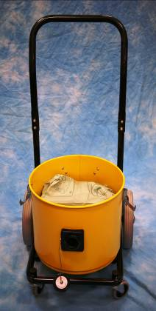
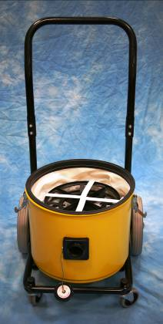
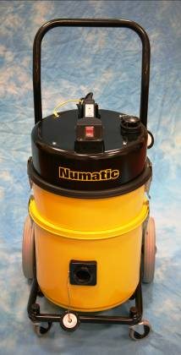
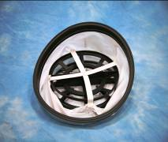
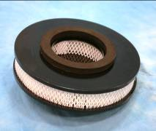
Numatic High Efficiency HEPA Filter Vacuum Cleaner (HZDQ 450-2): Triple Filter System
Duplex Module
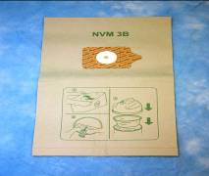
Filter Layer 1

The disposable paper filter Bag (NVM – 3B 1 layer microflo dust collection bag), filters to 0.5 microns and substantially improves the performance of the unit, it also simplifies the cleaning of the machine.
The dust bag incorporates a “trapit” enclosure system to contain collected dust.

Filter Layer 2

The Primary Permatex Pre-filter (each machine comes supplied with a spare pre-filter), filters to 0.5 microns and must always be used. To operate this unit without a pre-filter will result in permanent damage to the unit’s motor system.
The unit’s Primary filter must be replaced / cleaned and decontaminated each time the disposable collection bag is replaced.

Filter Layer 3

The HZ Micro HEPA Filter, filters to 0.3 microns and is the final filter that contaminated air passes through prior to it’s release back into the atmosphere. This filter is located and fixed within the duplex module of the vacuum.
The HZ Micro HEPA Filter will be subject to annual Dispersed Oil Particulate (DOP) Testing.

“Trapit” enclosure
“Trapit” enclosure

- Operating Procedures
The Numatic High Efficiency HEPA Filter Vacuum Cleaner is essentially a “dry machine” and must never be used for the collection of liquids. This vacuum cleaner must always be used with the Primary Permatex Pre-filter in place; operating this unit without a pre-filter will result in permanent damage to the unit’s motor system.

The correct operation of the machine relies on an adequate air movement system, air and dust are drawn through the hose and nozzle at the front of the unit, dust is trapped by the filters and the air exits through the air diffuser at the top of the unit. It is therefore essential that the dust caps are removed and replaced by the hose and air diffuser prior to use.

During maintenance procedures or removal of dust waste from practical areas, the appropriate Personal Protective Equipment (PPE) must always be worn; dust coat, goggles and suitable respiratory protection. The minimum level of respiratory protection that should be used for these tasks is an Alpha Solway FFP3 tight fitting disposable face mask, except for technicians (core skills technical) who, as a result of Face Fit Testing, have been issued with a Tornado T/Procap and T/Power Respiratory Protection Device.

  - When operating the vacuum cleaner in a contaminated environment, the operator must always wear appropriate PPE as outlined above.
  - Before use check that the dust caps have been removed and the hose and air diffuser are in place.
  - After use, and before leaving the contaminated area, the operator should remove all dust from the surface of machine itself by gently vacuuming the contaminated surfaces of the unit.

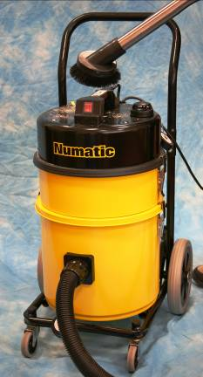

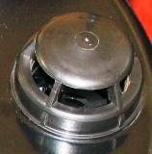
Air Diffuser

- Replacing the Dust Collection Bag
This machine is designed to collect hazardous dusts; hence any dust found within the machine or in its filters may be dangerous to your health. Both the dust collection bag and the pre-filter will capture materials greater than 0.5 microns, while the HEPA filter traps materials greater than 0.3 microns. The vacuum cleaner is dependant upon these filters to remove and trap wood dust and other harmful dust particles from the practical work area. As the condition of the filters directly affects the efficiency of the vacuum cleaner, it is essential that the filters are regularly cleaned and the dust collection bag replaced as require. Schools should note that dust collection bags are “single use” and disposable, no attempt should be made to empty and re-use contaminated bags.

  - Ensure that the vacuum cleaner is disconnected from the mains power supply.
  - When replacing the dust collection bag, the operator must always wear the appropriate PPE as outlined earlier in this document.
  - Ensure that a replacement dust collection bag, the “spare” Primary Permatex Pre-Filter, 2 disposable refuse sacks and disposable damp cloths / paper towels are available and to hand prior to undertaking step 2.4.
  - Carefully remove the top section of the vacuum cleaner; motor section and HEPA duplex module. Put them to one side, this will expose the Primary Permatex Pre-Filter.
  - Carefully remove the contaminated Primary Permatex Pre-Filter, and place to one side (inside a refuse sack to contain dust spillage – But do not discard). This step will expose the microflo dust collection bag.
  - Remove the dust collection bag and place it in one of the refuse sacks, taking care not to disturb the contents. In the event that the paper dust bag is damaged or split for whatever reason, additional care must be taken. Carefully remove the dust bag and its contents from inside the chamber, placing them immediately into a refuse sack. Using damp cloths / paper towels remove any excess dust remaining in the chamber, placing all used damp cloths / paper towels directly into the refuse sack.
  - With a disposable damp cloth / paper towel (or more if required), thoroughly clean the inside of the chamber. Deposit the contaminated cloths / paper towels in the disposable refuse sack.

(Note: Schools who have two High Efficiency HEPA Filter Vacuum Cleaners can vacuum any excess dust from the chamber as opposed to using damp cloths.)
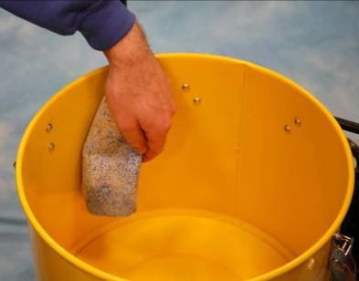

  - Carefully fit a new dust collection bag, ensuring a good fit onto the nozzle.
  - Insert a clean Primary Permatex Pre-Filter; make use of the spare one provided with the vacuum.
  - Replace the top section of the vacuum cleaner and secure in place with the retaining clips provided.
  - Test the vacuum cleaner and ensure its proper operation.
  - Using the vacuum and cleaning tools provided, thoroughly clean the contaminated Primary Permatex Pre-Filter (removed at the start) and store it safely as the “spare” for the next filter bag change.
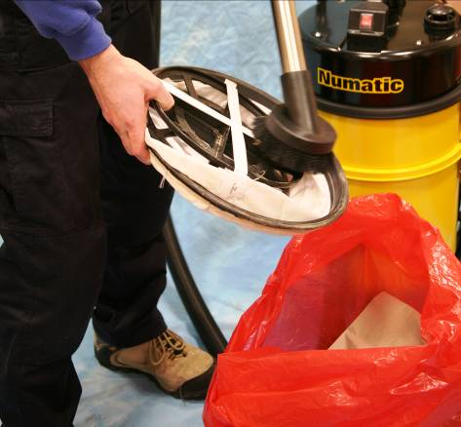

  - Finally secure the refuse sack and place it inside the second sack, secure and dispose of as general waste within the school disposal system.

- Maintenance of Hoses and Accessories
All hoses, brushes, extension poles, adaptors etc. should be inspected before and after use to ensure that they remain in good working order. Replace worn accessories as required via TSS.

- Safe Storage
To prolong the working life of the vacuum cleaner and to ensure it is always in good working order, it is essential that it is stored appropriately.
  - As stated in section 1 above; after use, before leaving the contaminated area, the operator should remove all dust on the surface of the machine itself by gently vacuuming any contaminated surfaces.
  - Carefully wind the cable around the handle and secure in place.
  - All hoses and accessories should also be stored safely.

- Fault Finding
The following are common faults that may occur when using the Numatic High Efficiency HEPA Filter Vacuum Cleaner (HZDQ 450-2).
  - “Machine will not start”: If the machine will not start, check it is switched on at the mains and at the unit; check there is power to the room or finally ensure the plug fuse is intact and operational.
  - “Low Flow” Indicator Flashing: If the “Low Flow” indicator flashes, this is because of insufficient air flowing through the unit. Check that the dust caps have been replaced by the hose and the air diffuser. Insufficient air flow can also be due to a blockage in the hose or excessively contaminated filters. Isolate the unit from the mains power supply, locate possible blockages, clear and test the unit is operational.
  - “Loss of power”: If the machine stops while in use for no apparent reason, leave for a few minutes, then try to restart. The vacuum is fitted with an “over-temperature” device which operates to cut the power to prevent damage to the motors. If the over-temperature device has operated, this will indicate that there is not sufficient air flow through the vacuum. This will most likely be due to a blockage in the hose or excessively contaminated filters. Isolate the unit from the mains power supply, locate possible blockages, clear and test the unit is operational.
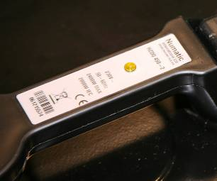

“low-flow” indicator

  - “Static electric sparks”: Some vacuums may after prolonged use produce static electric sparks between the metal clips or between metal parts in the duplex module, this is due to the rubber seal on the Primary Permatex Pre-Filter. To overcome this problem, TSS have produced an “earth strap” which should be attached between the top of the vacuum and the rear of the unit. In order to establish a good earth it is necessary to scrape away a small amount of paint at the point where the clip secures to the vacuum. (see below)
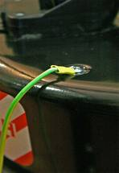
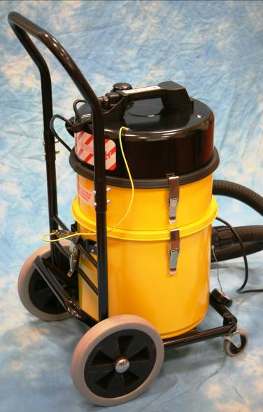
Earth fixing at top of vacuum
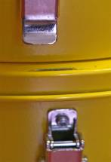
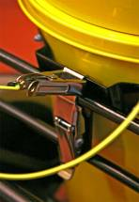
Earth Strap
Clip at rear of vacuum
Exposed paintwork
Earth connection at top of vacuum
Exposed metal at clip
Annual Dispersed Oil Particulate (DOP) Testing

This test comprises of introducing a measured and controlled challenge to the HEPA filter (upstream) and recording the result using either a photometer or a valometer at the output (downstream). The challenge test consists of a particulate mist from vaporised food grade oil (Ondina), non-toxic and non irritant. The HEPA filter is deemed to be 99.997% efficient at containing respirable dust of 0.3microns or more. Therefore the pass conditions are an output (downstream) reading of 0.003% or less. The DOP test is also inclusive of an Electrical Safety Test as well as a microflow dust collection bag change.
TSS will uplift the HEPA Vacuum Cleaners annually for the dispersed oil particulate (DOP) testing, the cost of this test is presently (2009) £20.00 per unit and this will be met by individual establishments. If a HEPA Vacuum Cleaner fails the DOP test, then it will require the HEPA filter to be replaced. Please note; that units which have not been tested cannot continue to be used as part of the councils COSHH dust control measures.

For any further advice regarding the use, maintenance, repairs or accessing spare parts for the Numatic High Efficiency HEPA Filter Vacuum Cleaner (HZDQ 450-2) please contact:
Technician Support Service
C/o The Glasgow Gaelic School
147 Berkeley Street
Glasgow G3 7HP

Telephone: 0141 276 8550
Fax: 0141 276 8551
Email: admin@TSS.ea.glasgow.sch.uk
Numatic High Efficiency HEPA Filter Vacuum Cleaner (HZDQ 450-2): Accessories

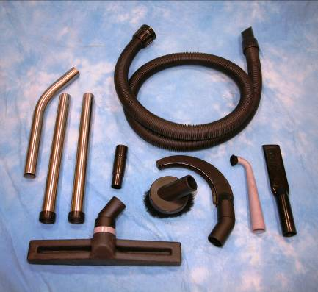
1
2
3
4
5
6
8
7

The Numatic High Efficiency HEPA Filter Vacuum Cleaner (HZDQ 450-2) has available an extensive range of accessories;
Number | Description | Order Code | Cost
1 | 2.4M Nuflex Threaded Hose | NVB-60102 | £23.69
2 | 3-piece Stainless Steel Tube Set | NVB-602917 | £33.34
3 | 38mm to 32mm Adaptor | NVB-602159 | £3.56
4 | 152mm Rubber Brush with Soft Bristles | NVB-602161 | £16.08
5 | 200mm Banana Pipe Cleaning Tool | NVB-602169 | £21.32
6 | 300mm 90Deg Rubber Nozzle with Brush | NVA-601177 | £8.29
7 | 305mm ABS Crevice Tool | NVB-602160 | £6.68
8 | 400mm Widetrack Brush Nozzle | NVB-602431 | £23.69
Filter 1 | NVM – 3B 1 layer microflo dust bag – pack of 10 | NVM-604103 | £12.23
Filter 2 | Primary Permatex Pre-filter | NVM-604116 | £21.32
Filter 3 | HZ Duplex Micro HEPA Cartridge | NVM-604125 | £107.59
Cable | Nucable Connection | 236011 | £13.95
 | Air Diffuser | NMV-604151 | £5.88
* Prices correct at time of printing

